**1. Register Screen**

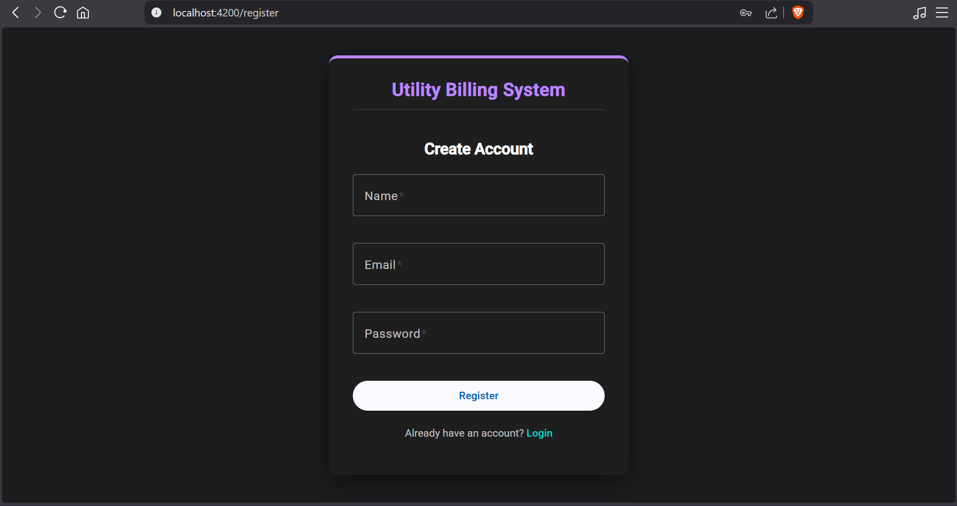

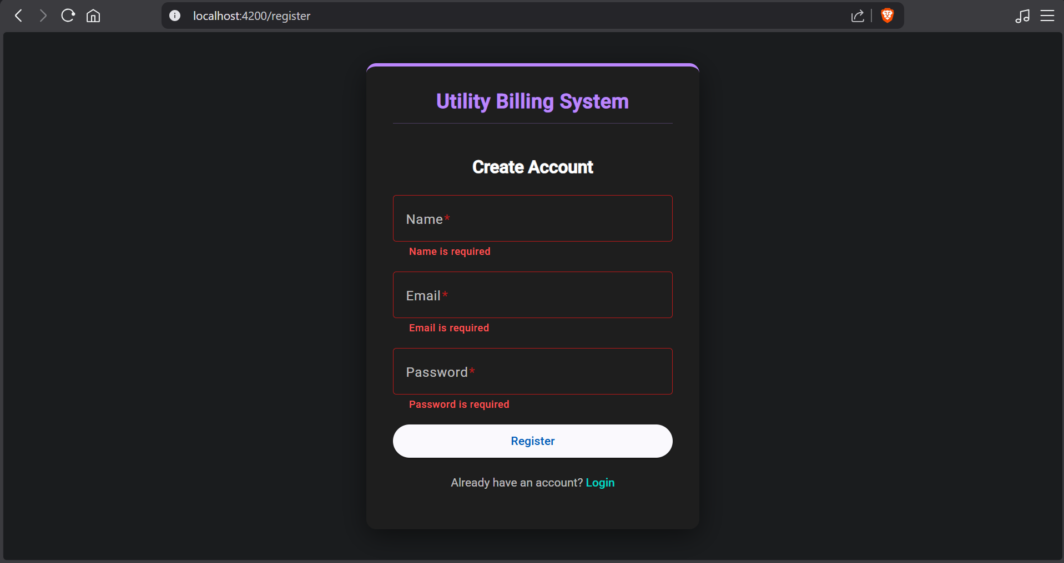

**2. Login Screen**

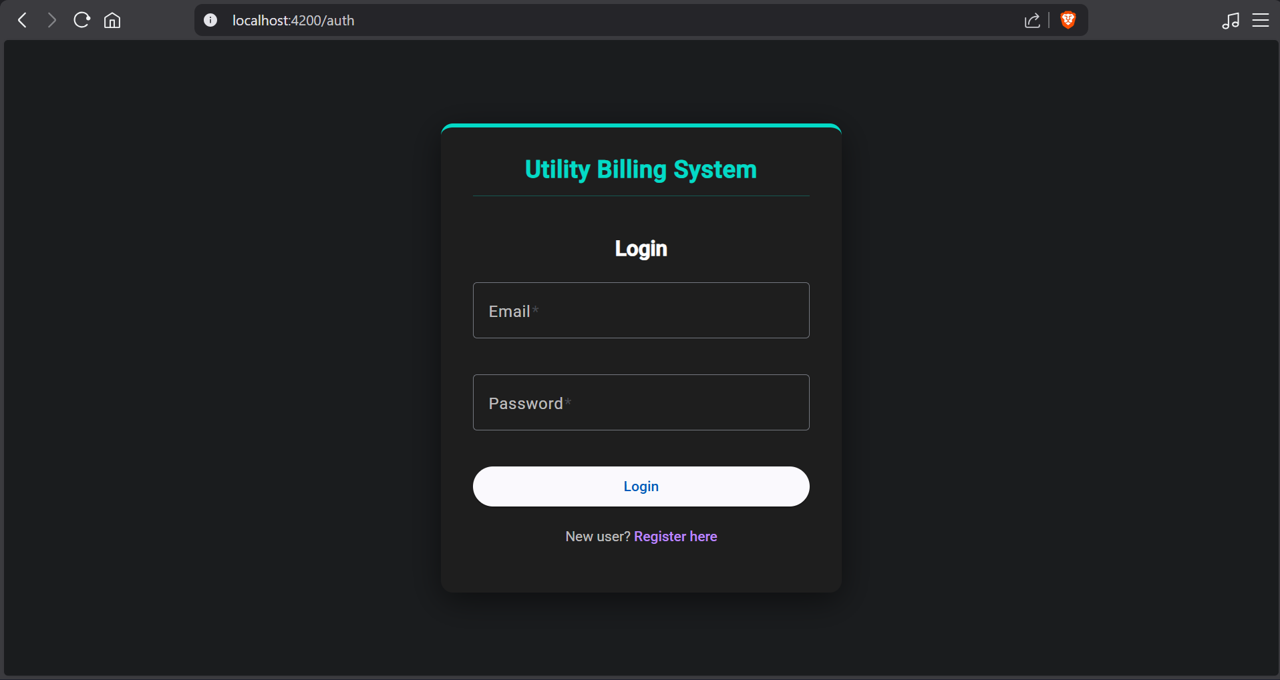

**Admin**

**3. Admin Dashboard**

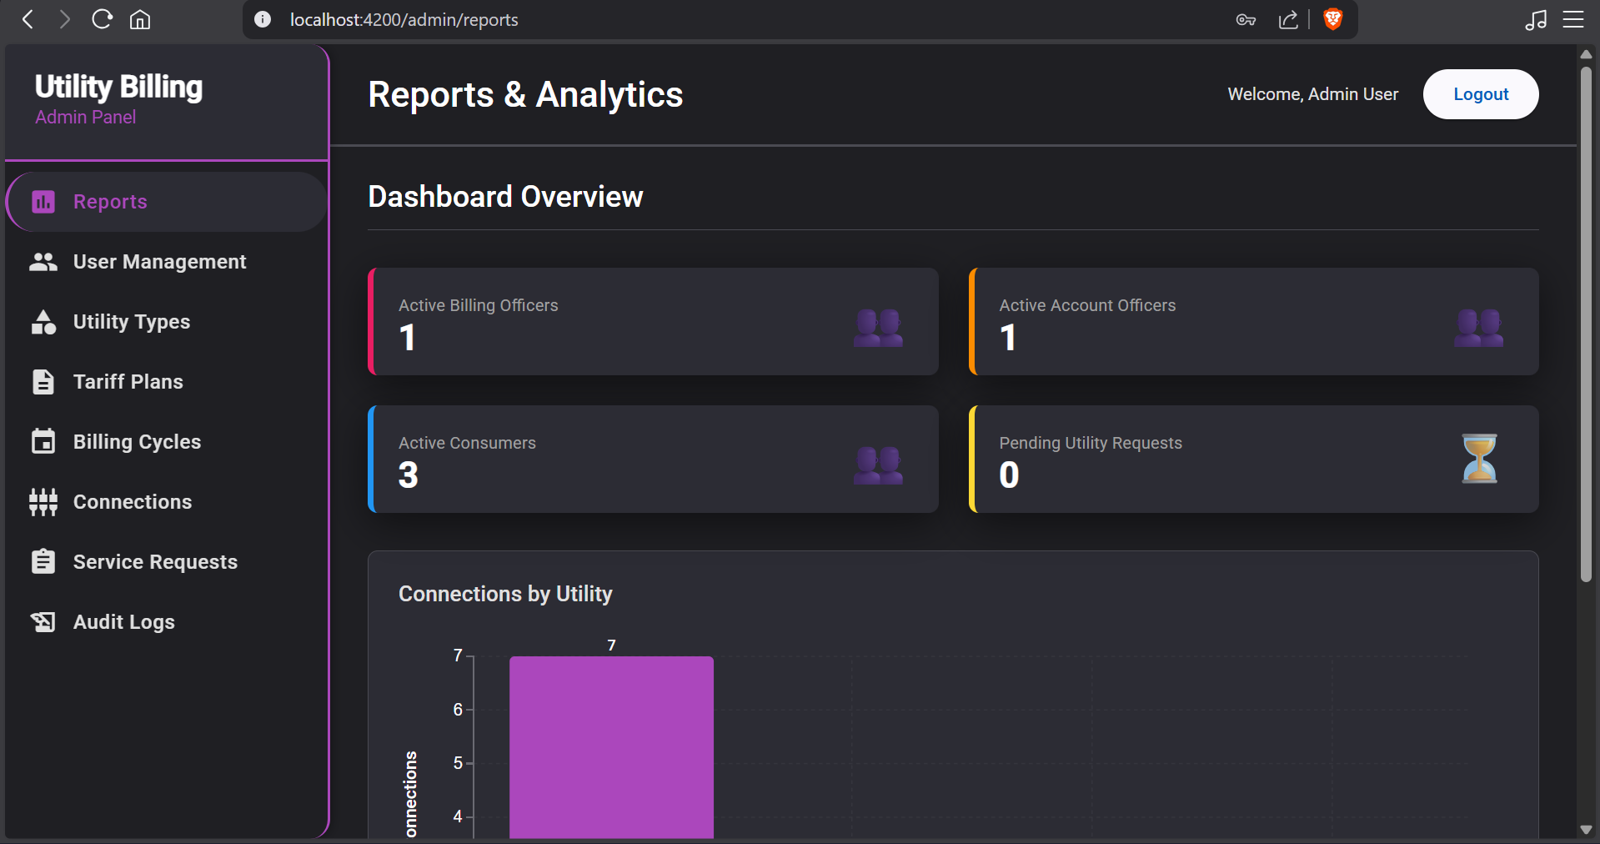

**4. Admin - User management**

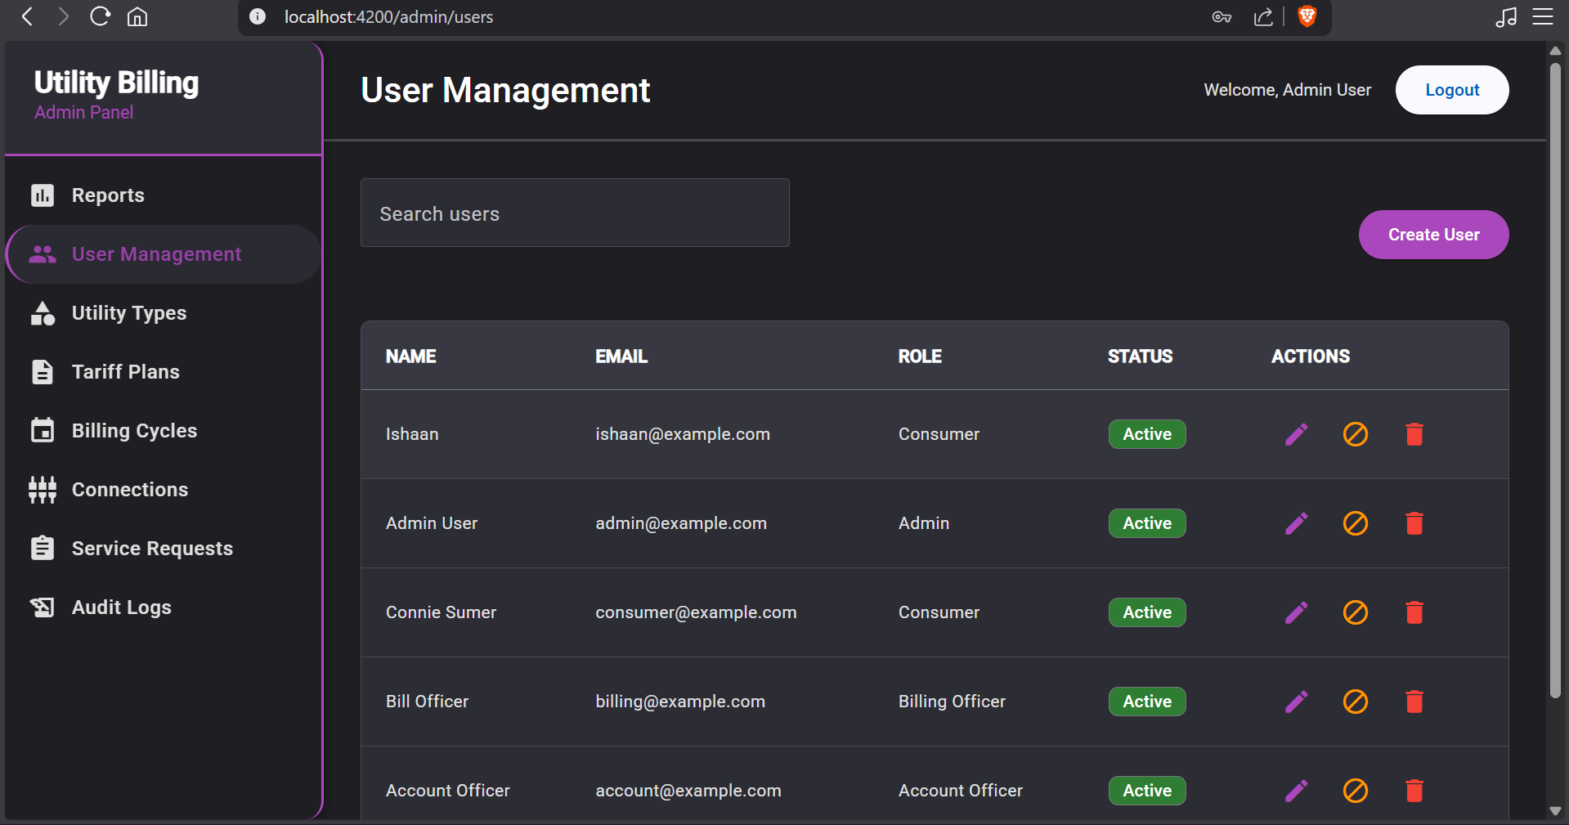

**5. Admin - Utility Types**

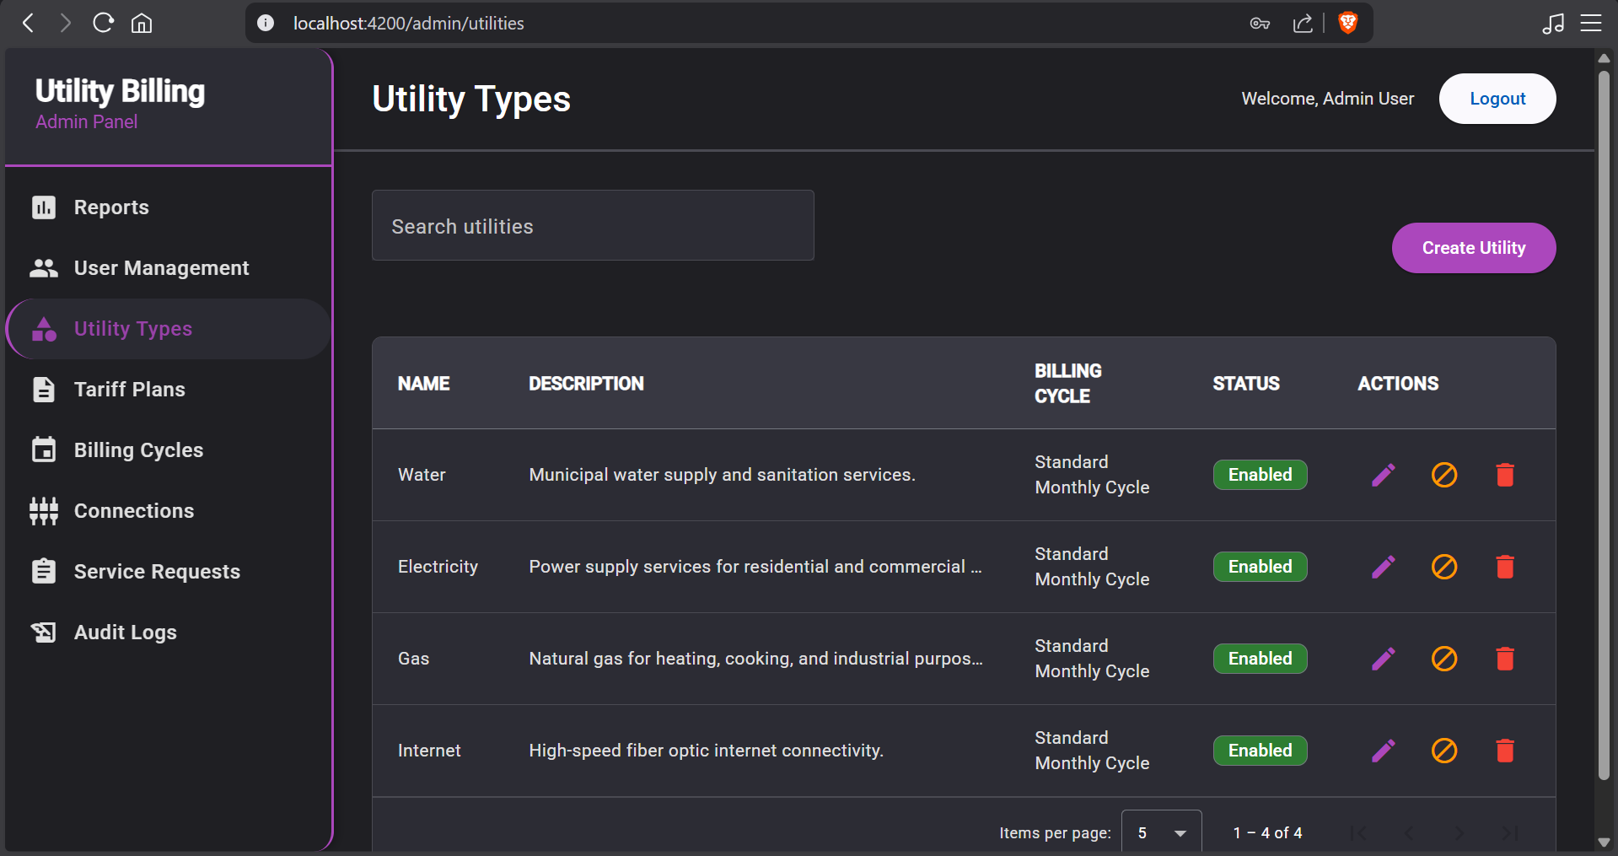

**6. Admin - Tariff Plans**

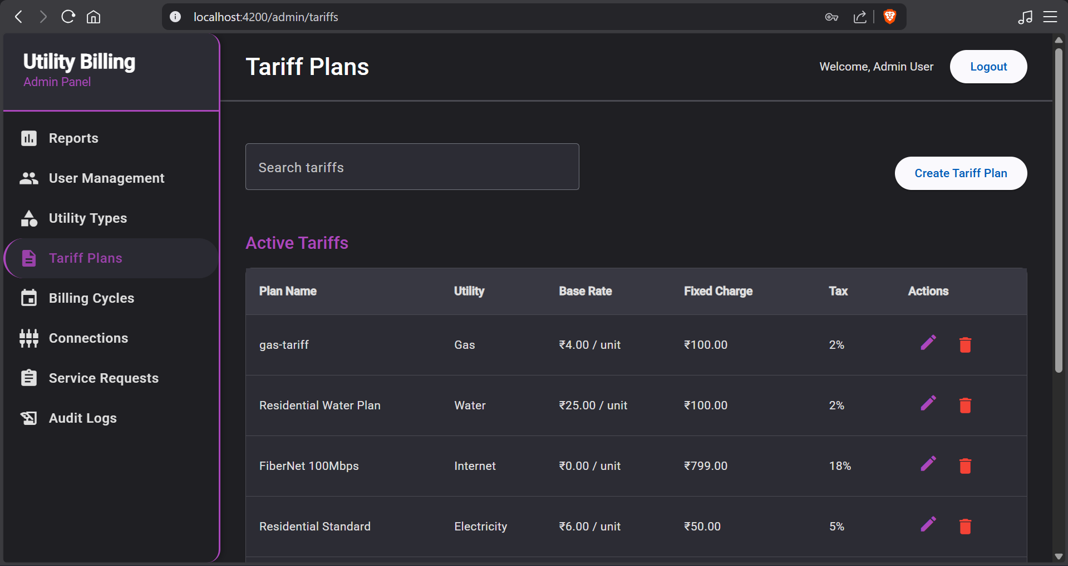

**7. Admin - Billing Cycles**

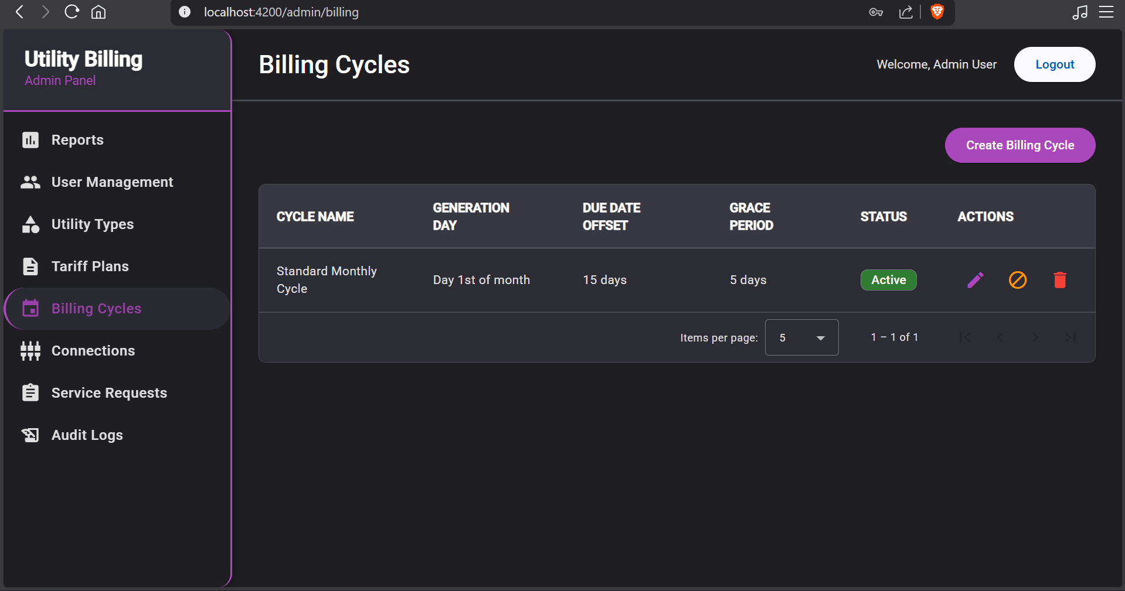

**8. Admin - Connections**

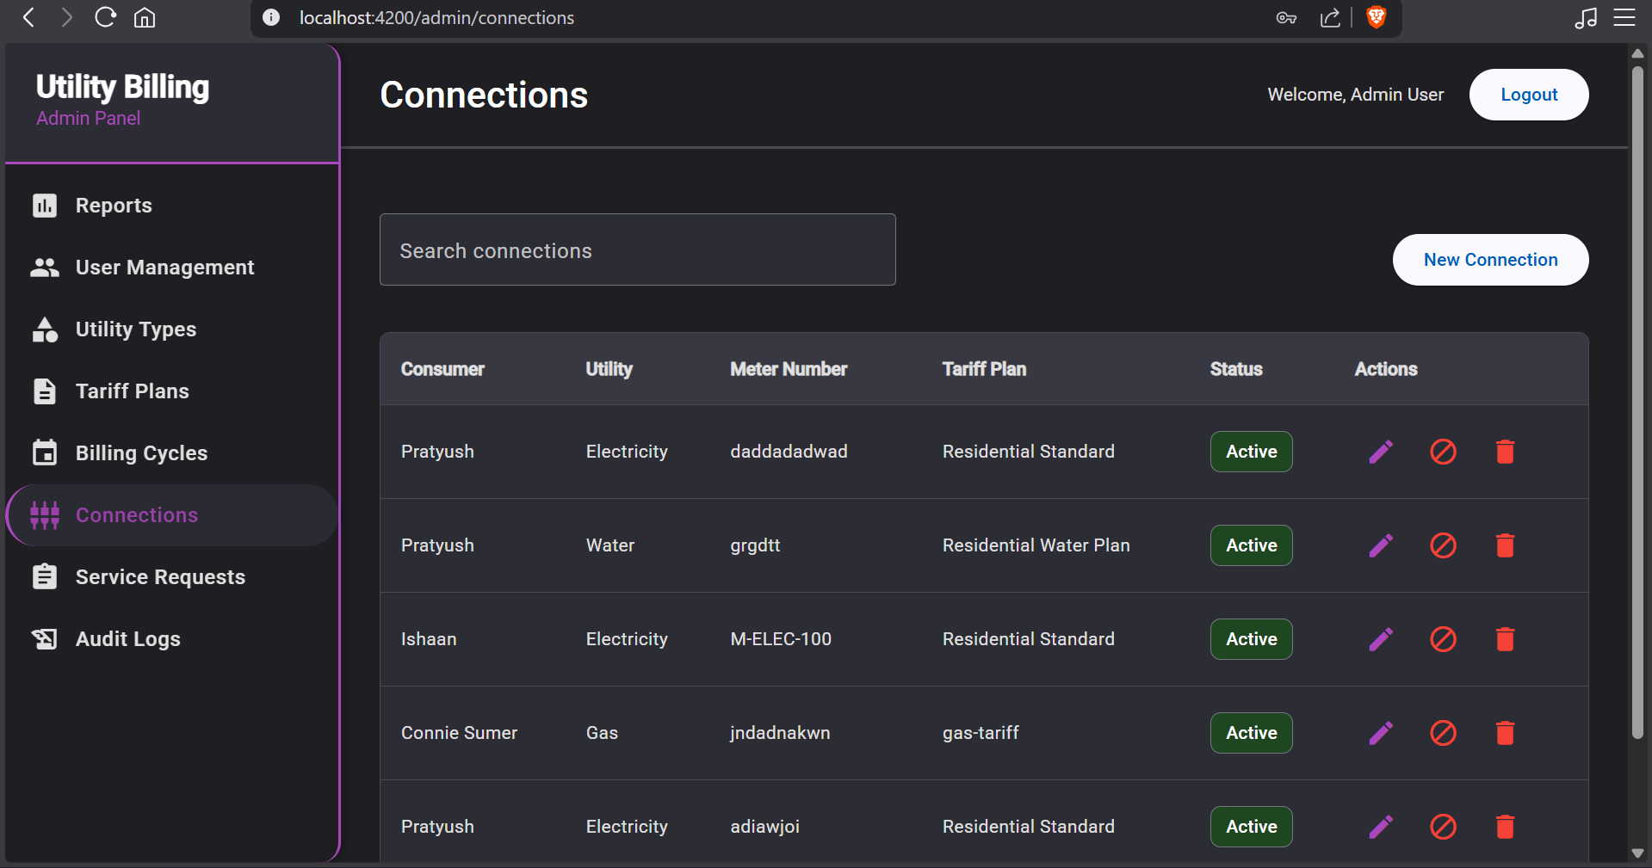

**9. Admin - Service Requests**

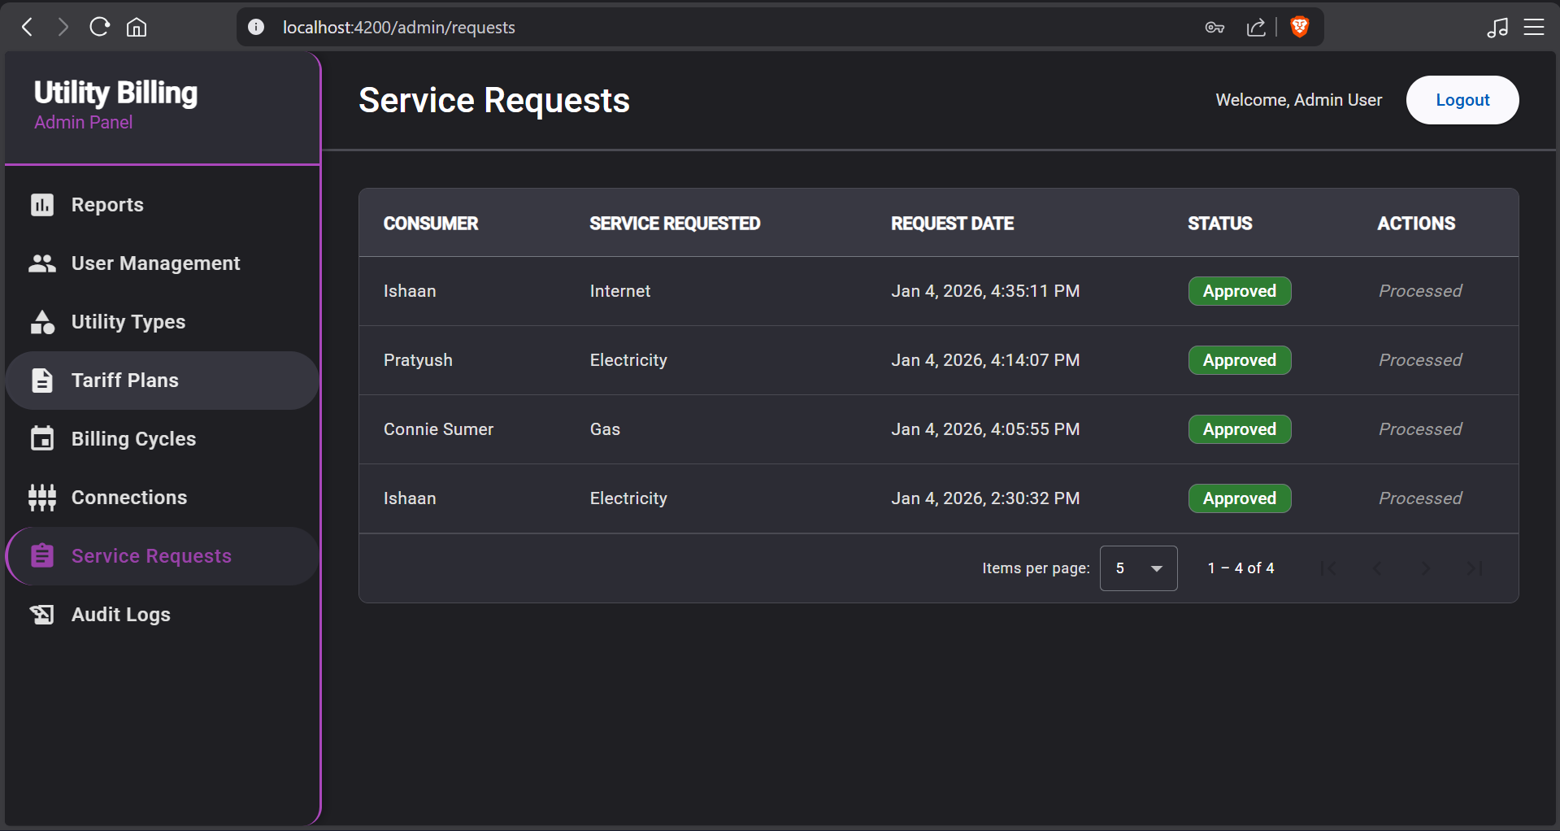

**10. Admin – Audit Log**

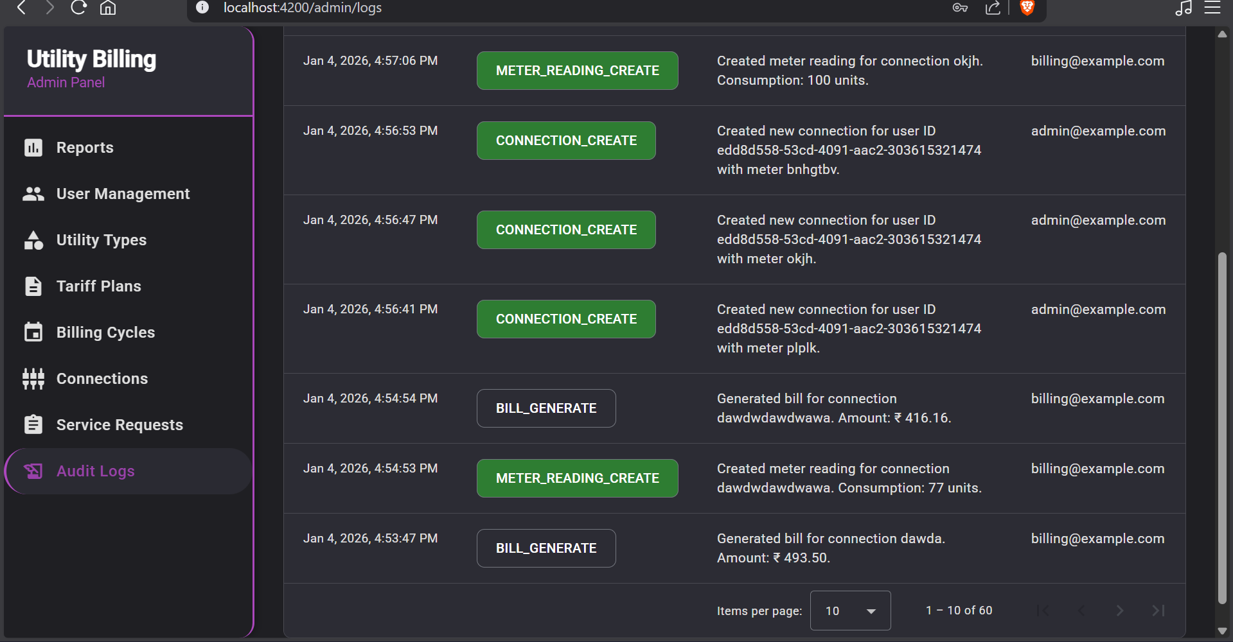

**11. Admin – Error message when admin tries to delete user with unpaid bills**

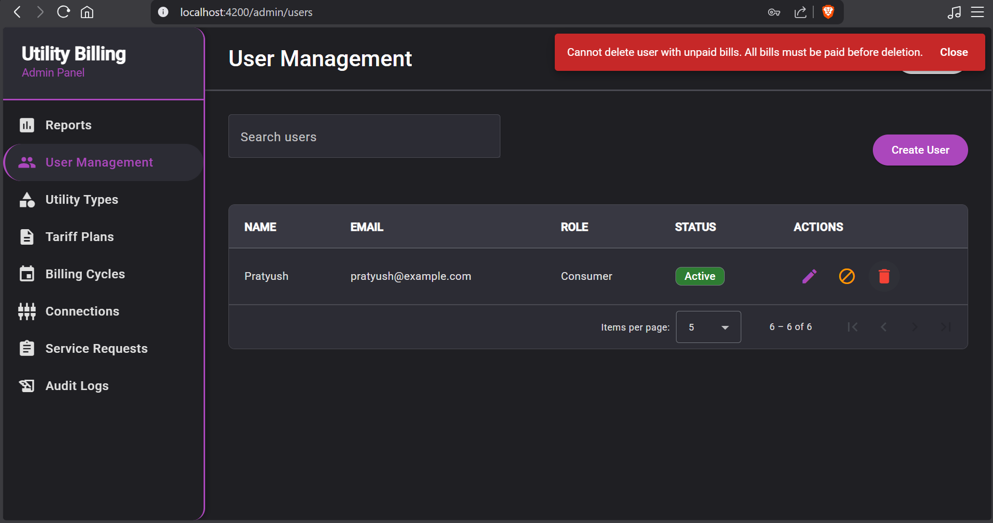

**12. Admin – Error message when admin tries to disable utility with active connections**

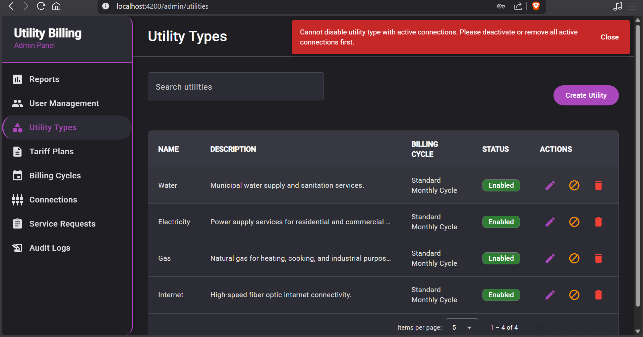

**13. Admin – Error message when admin tries to edit tariff before all meter readings have been recorded**

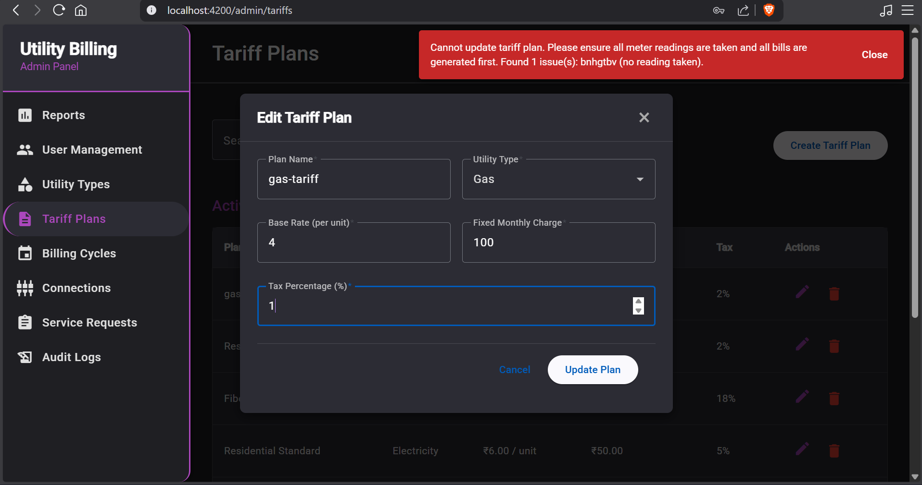

**14. Admin – Error message when admin tries to delete tariff plan with active connections**

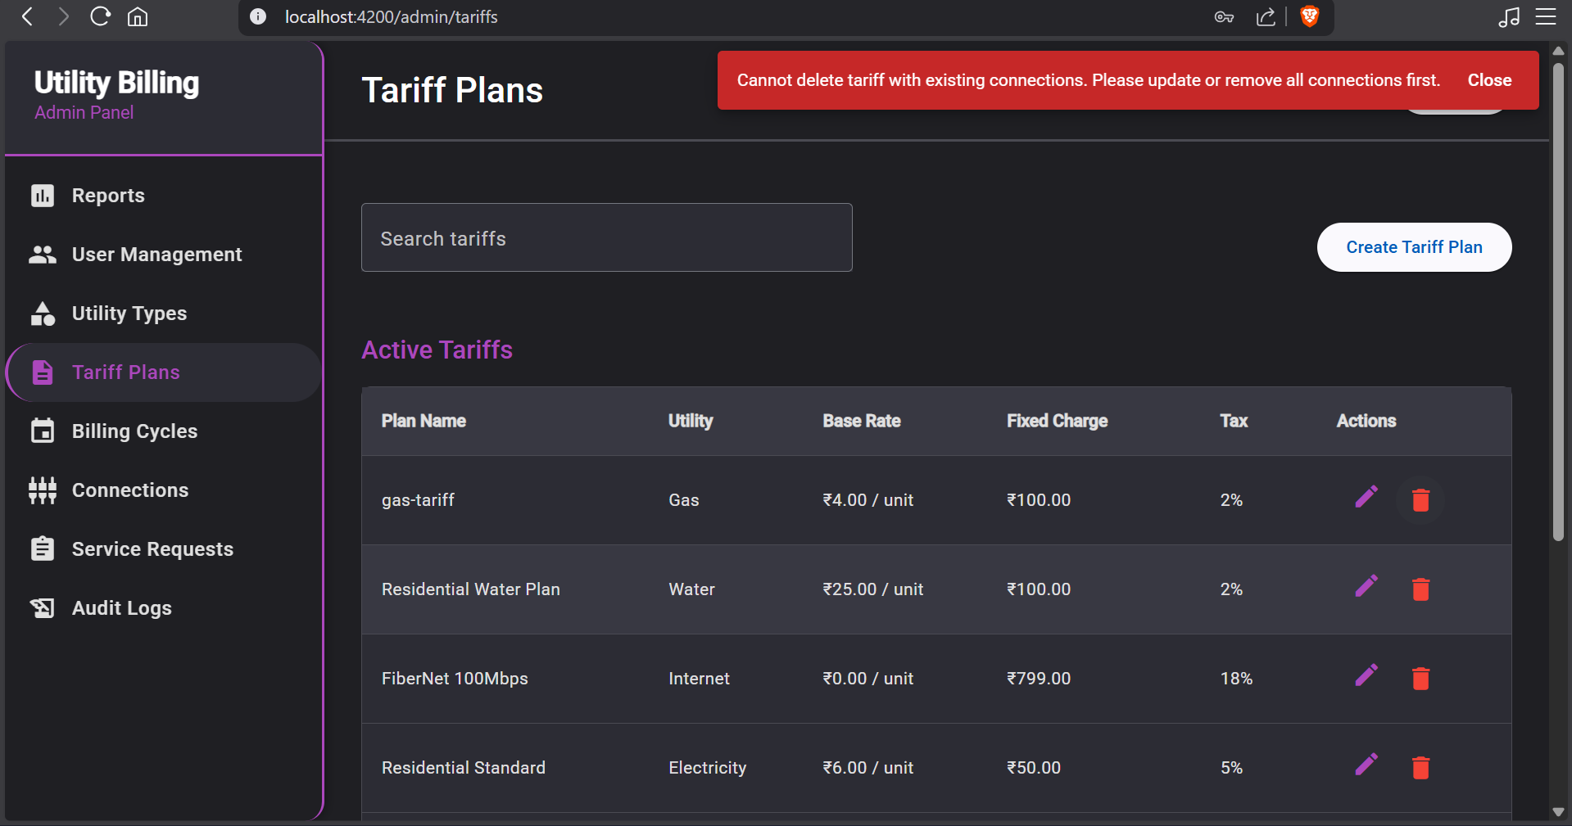

**15. Admin – Error message when admin tries to deactivate billing cycle with active utility types**

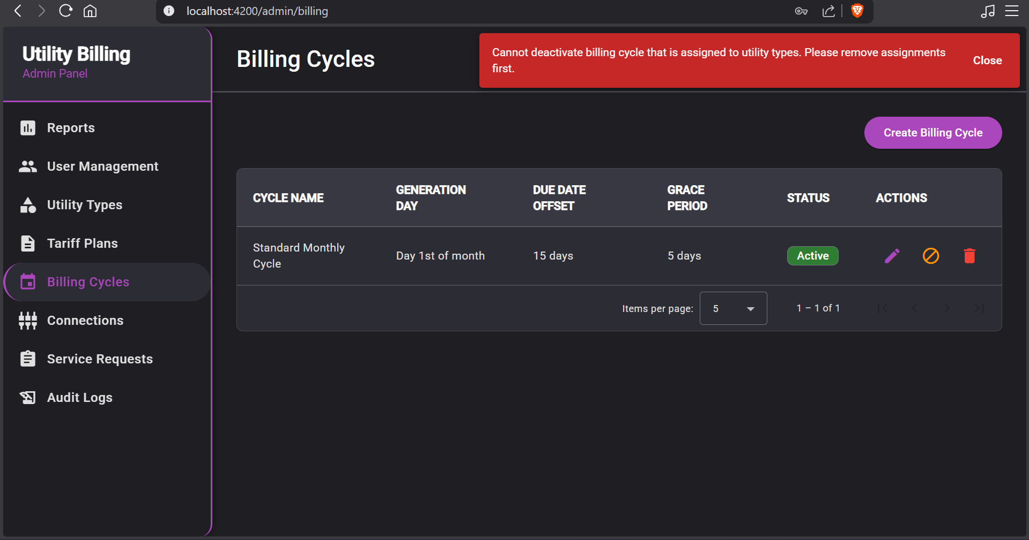

**16. Admin – Error message when admin tries to delete Consumer with unpaid bills**

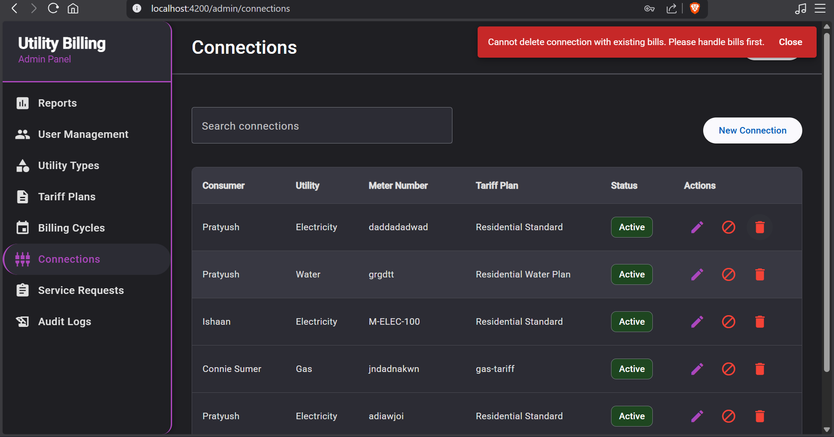

**17. Admin – Create user form**

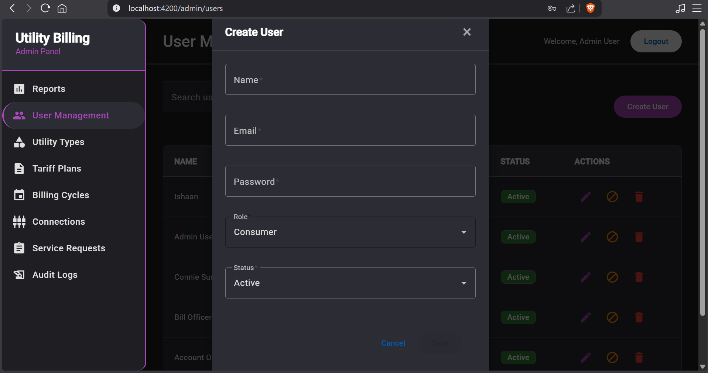

**18. Admin - Create utility form**

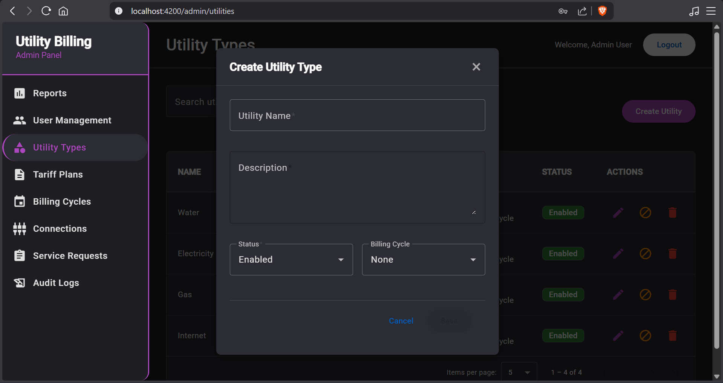

**19. Admin – edit utility form**

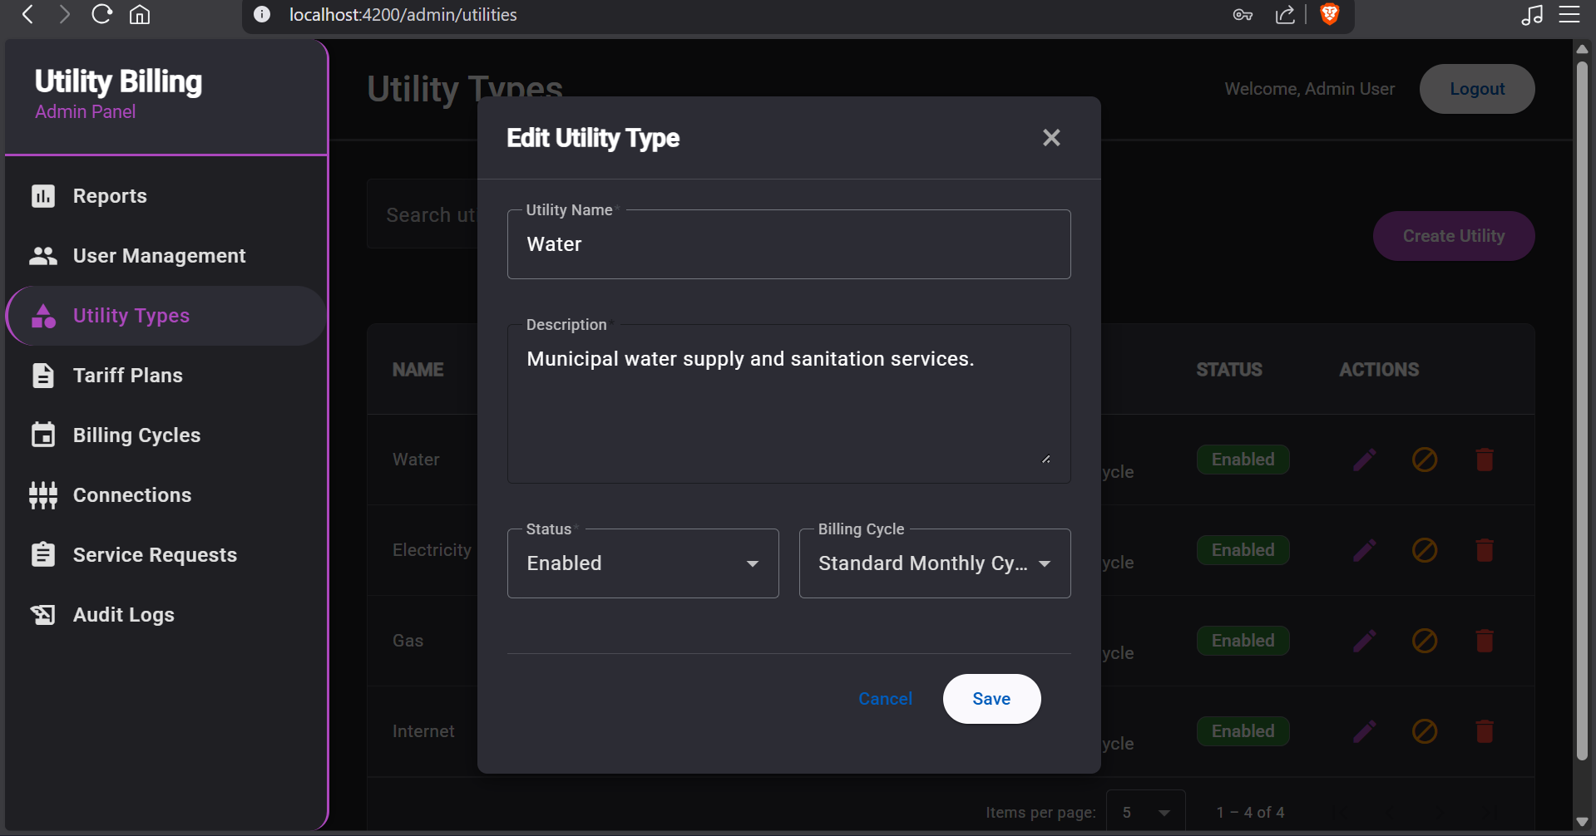

**20. Admin – edit tariff form**

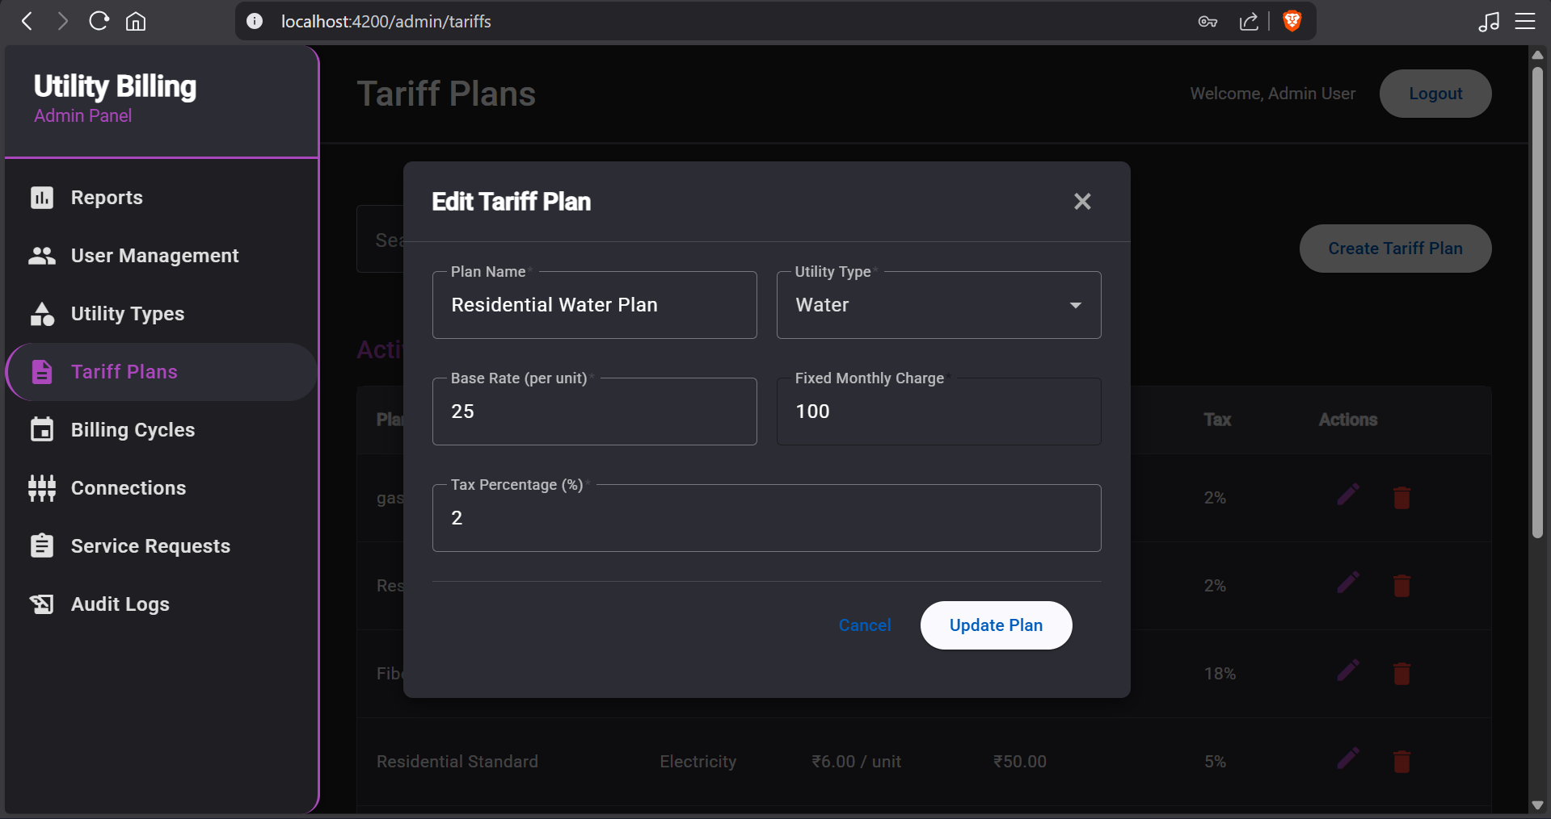

**21. Admin – Create billing cycle form**

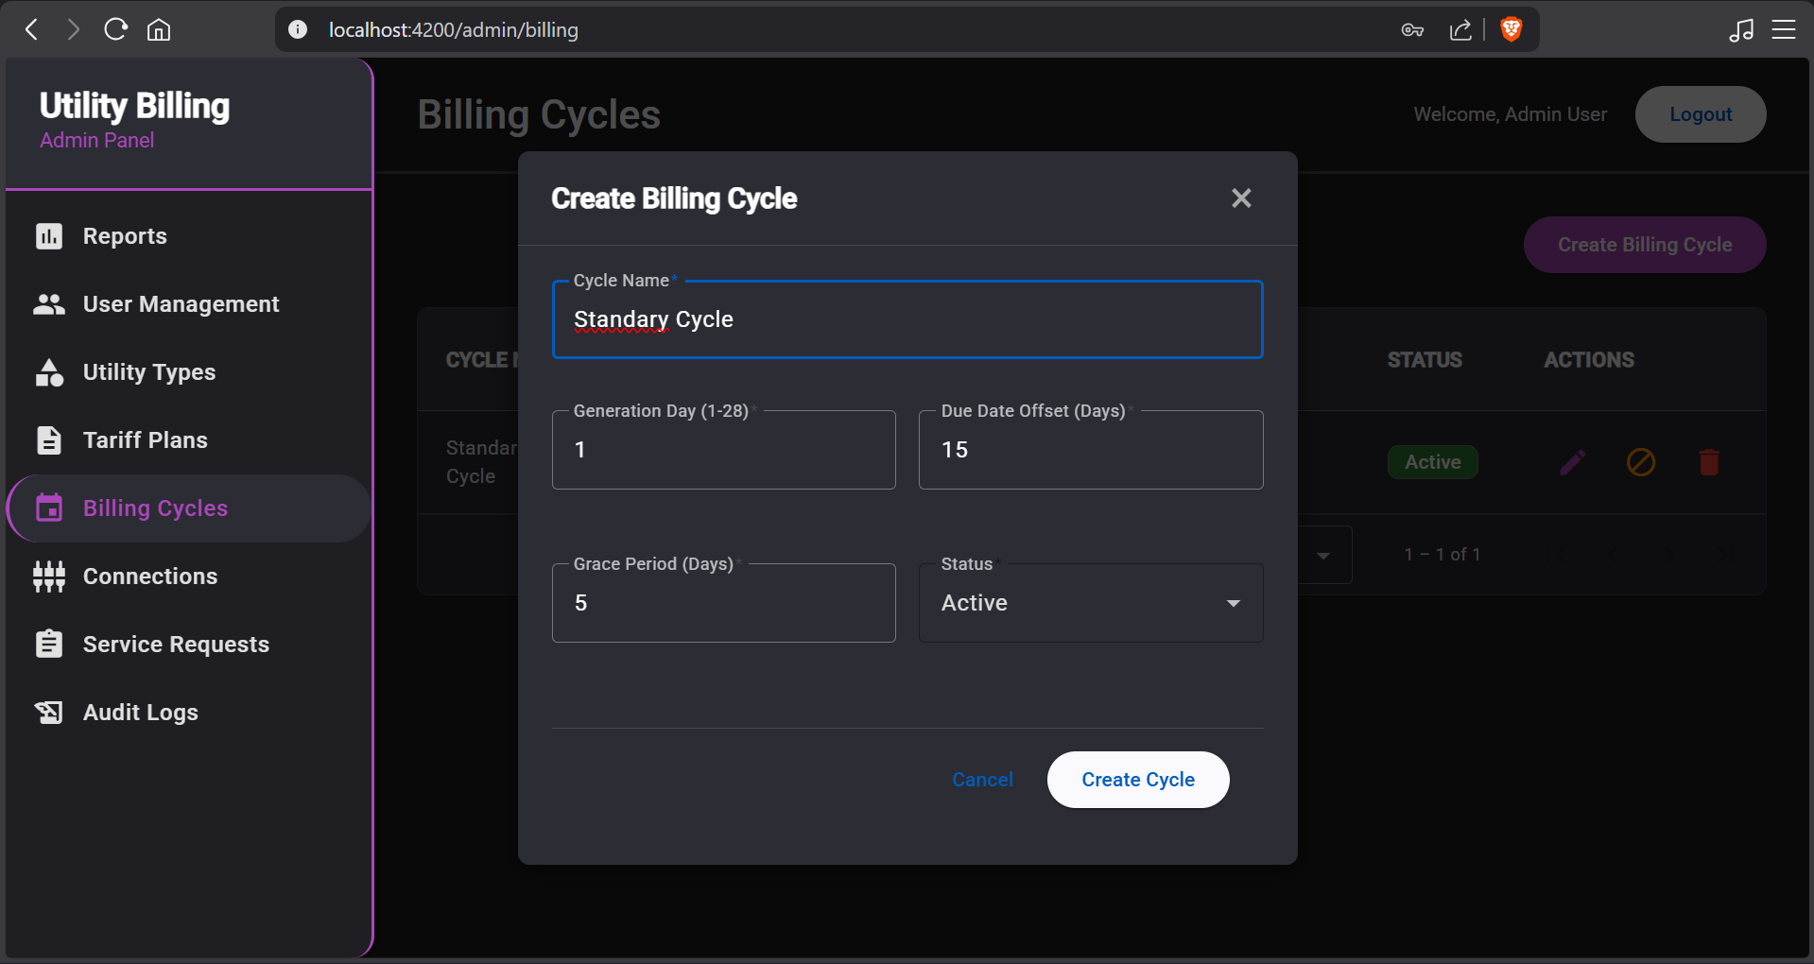

**22. Admin – Create new connection form**

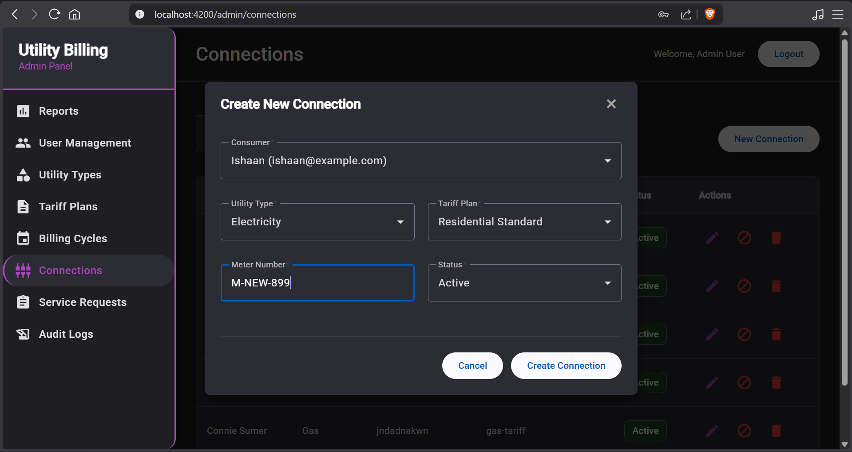

**BILLING OFFICER (BO)**

**23. BO – Meter Reading Entry page**

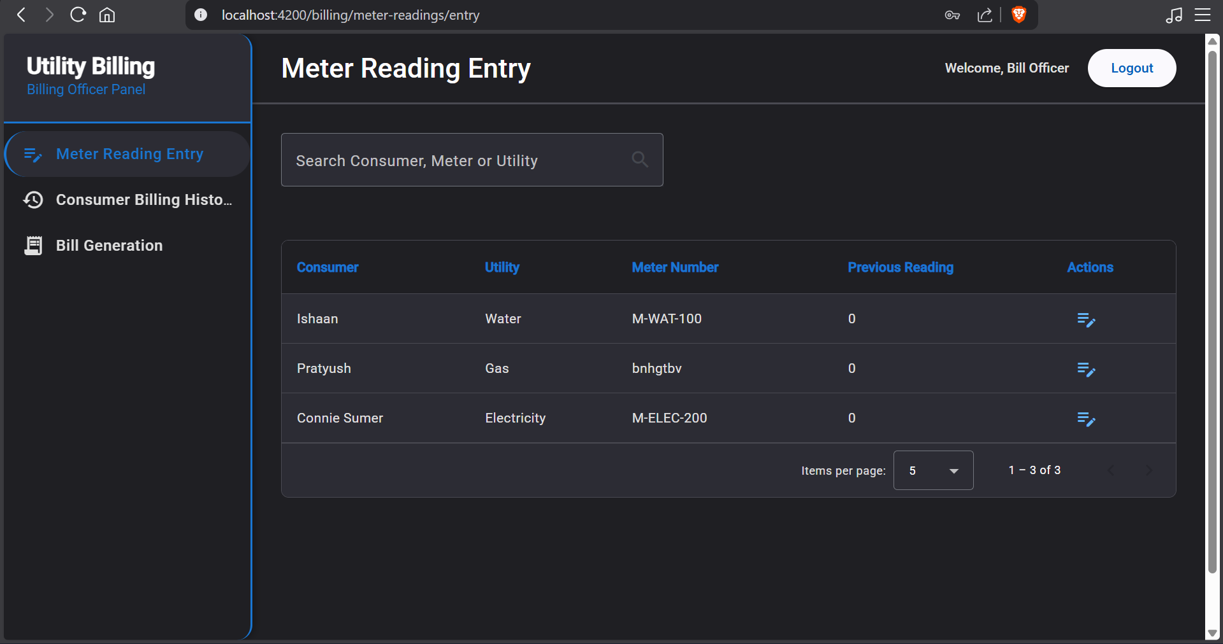

**24. BO - Consumer Billing History page**

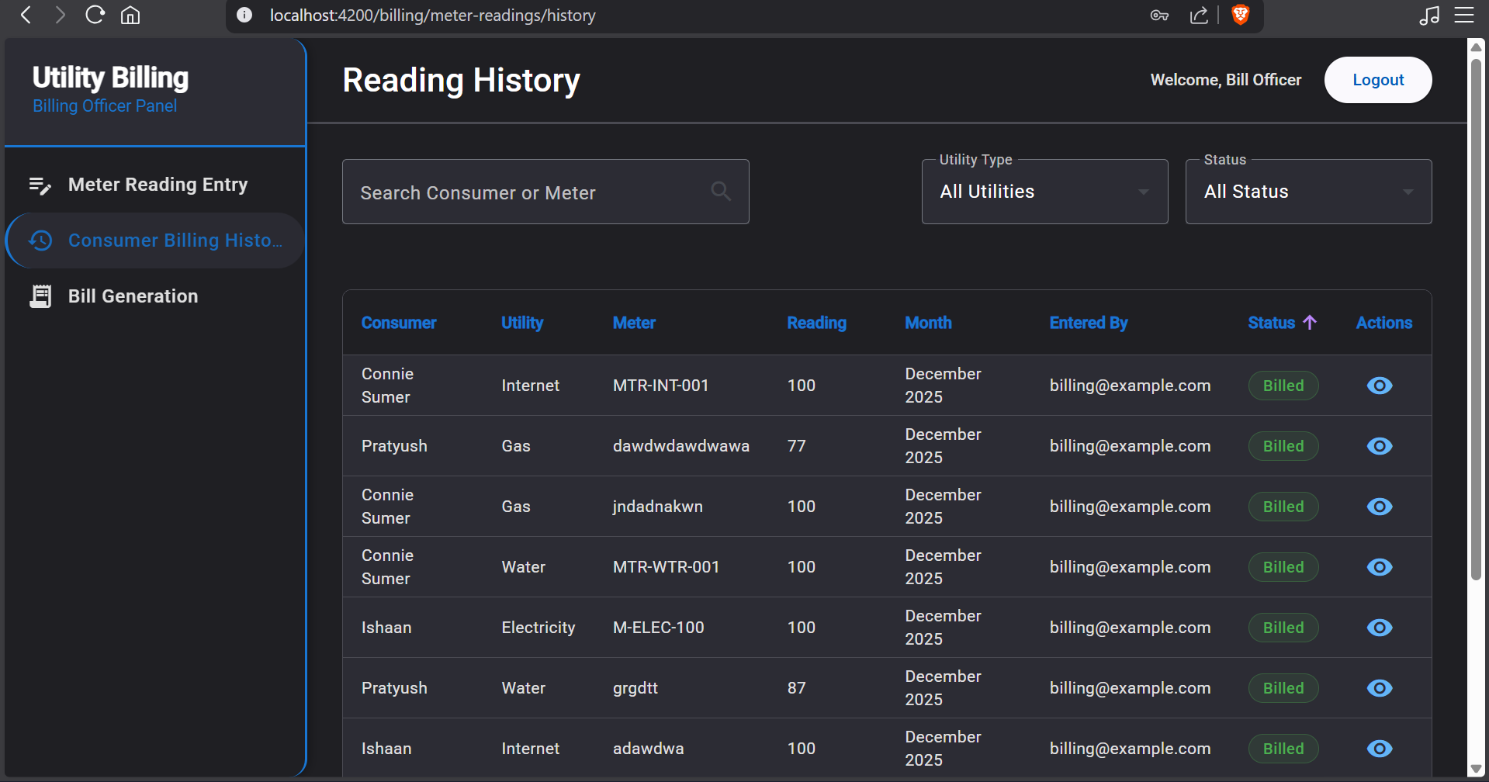

**25. BO – Bill Generation page**

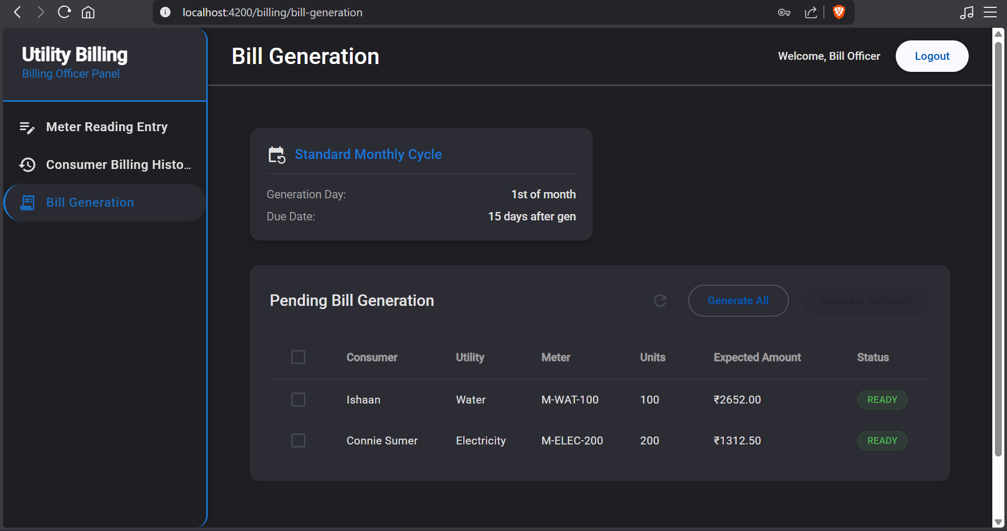

**26. BO – Meter reading entry form**

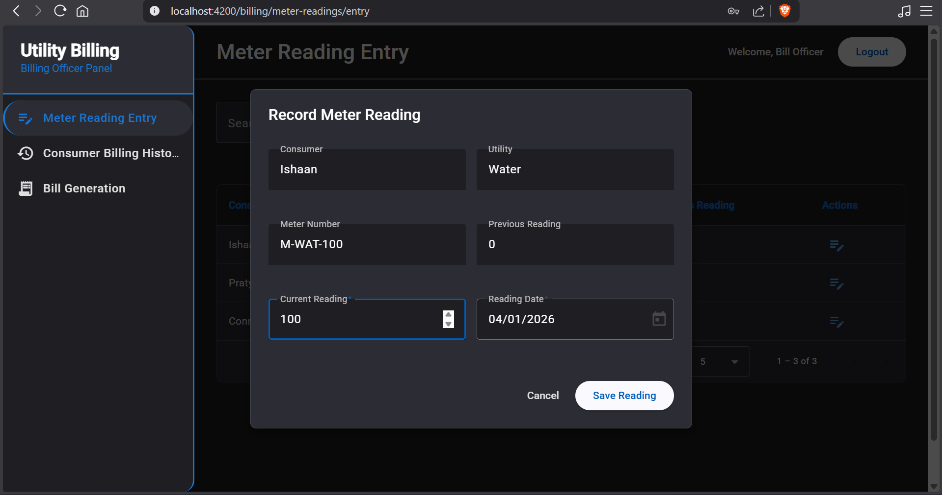

**27. BO – Meter reading details form**

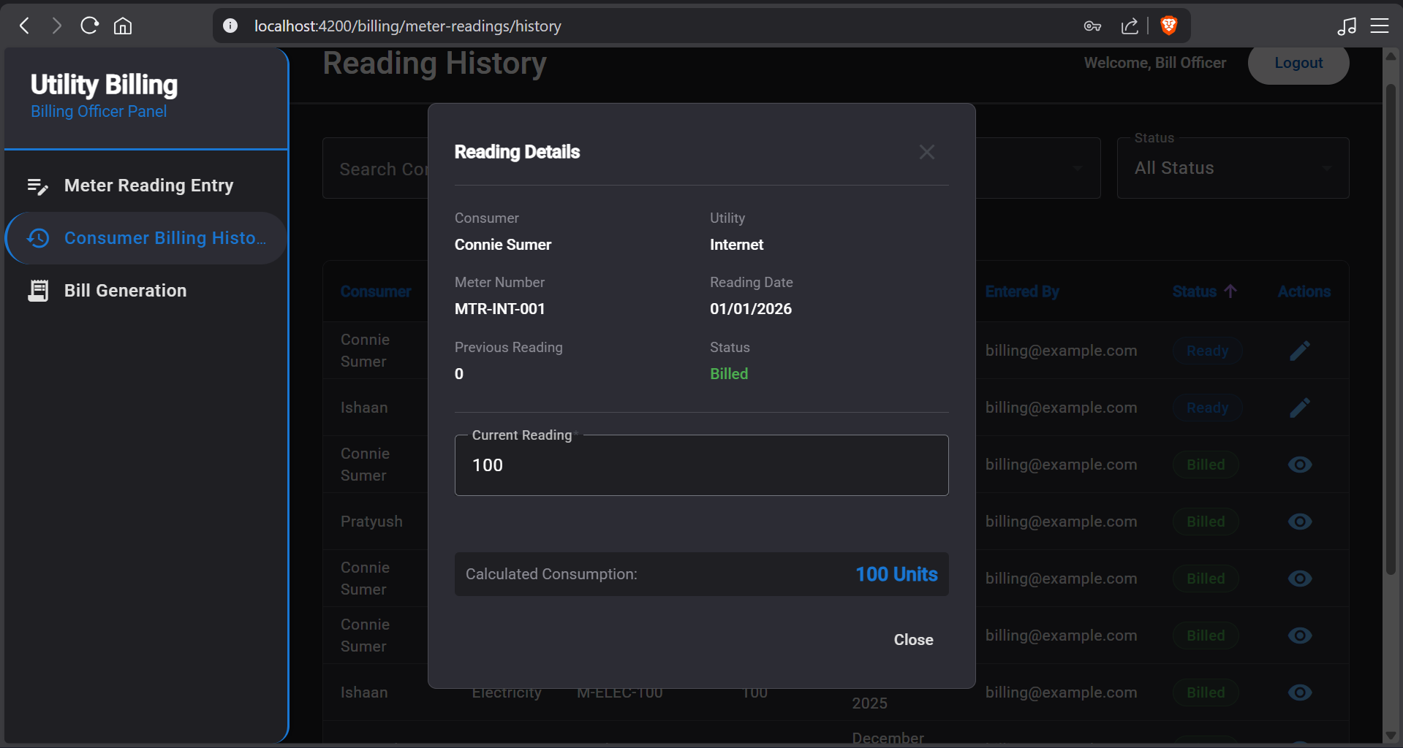

**28. BO – Confirm Bill generation popup**

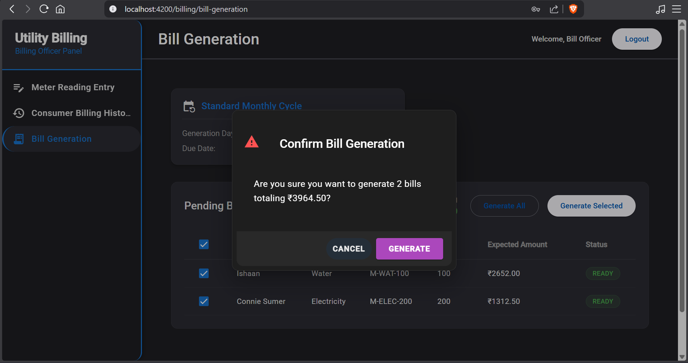

**Account Officer (AO)**

**29. AO – Dashboard**

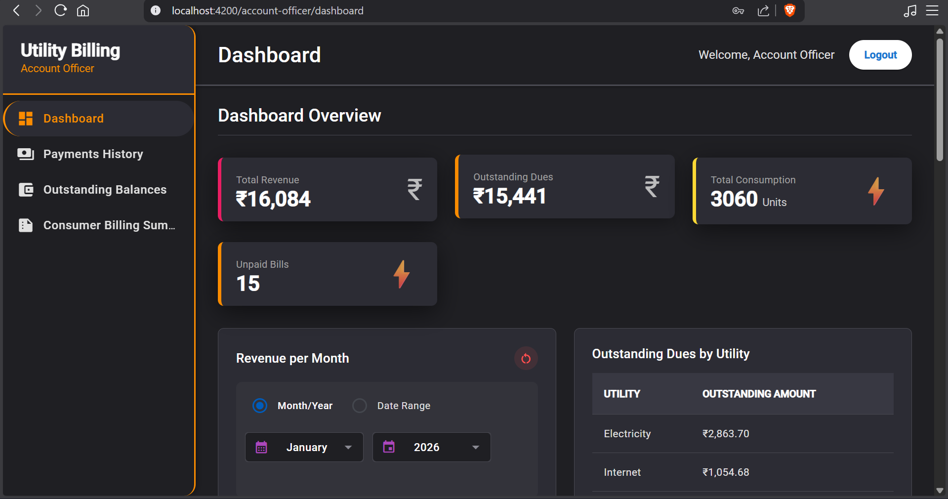

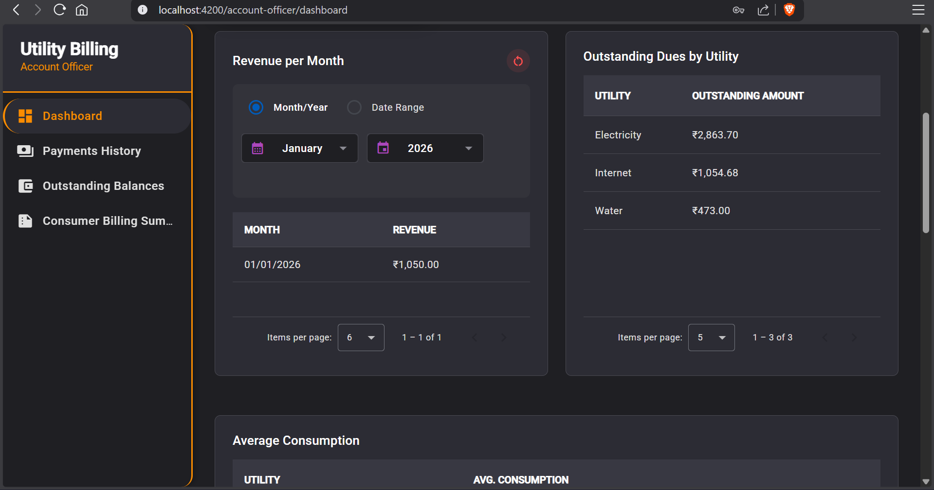

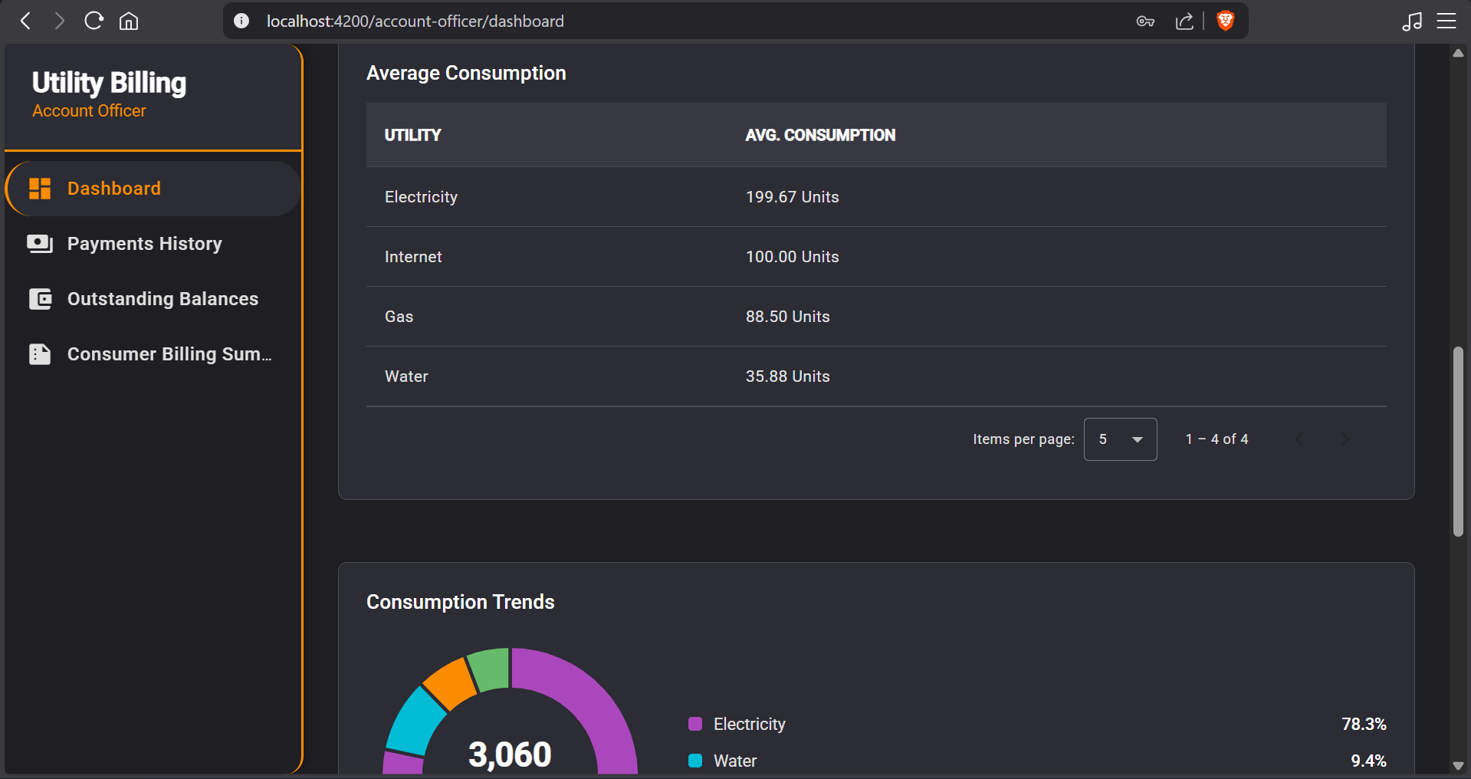

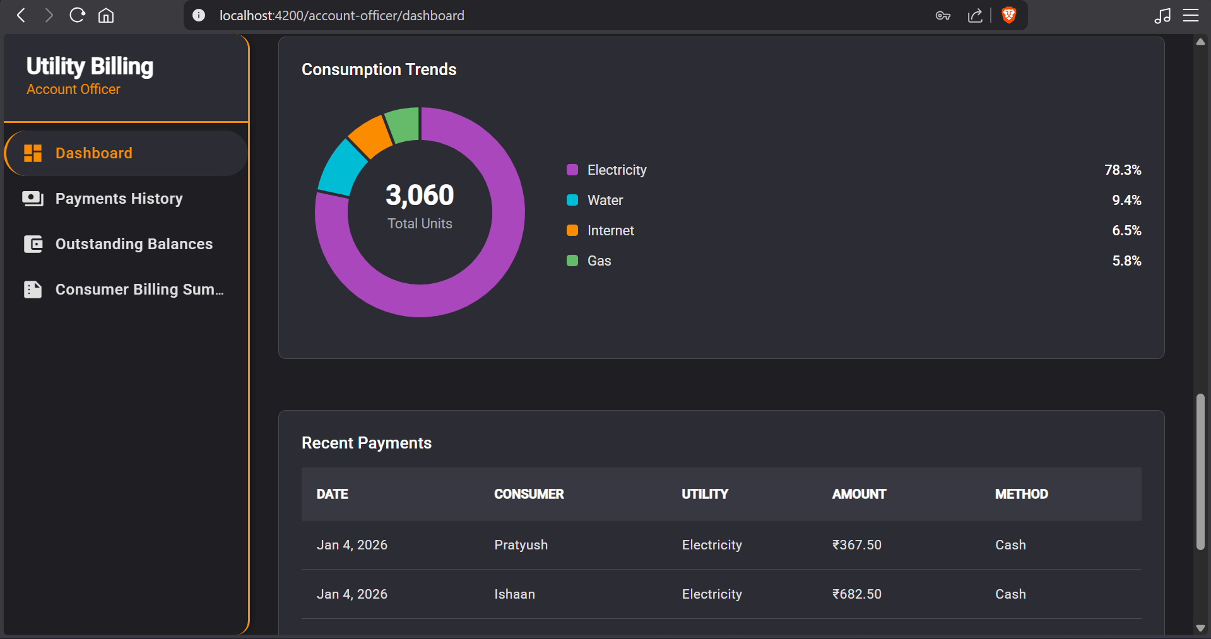

**30. AO – Payments history page**

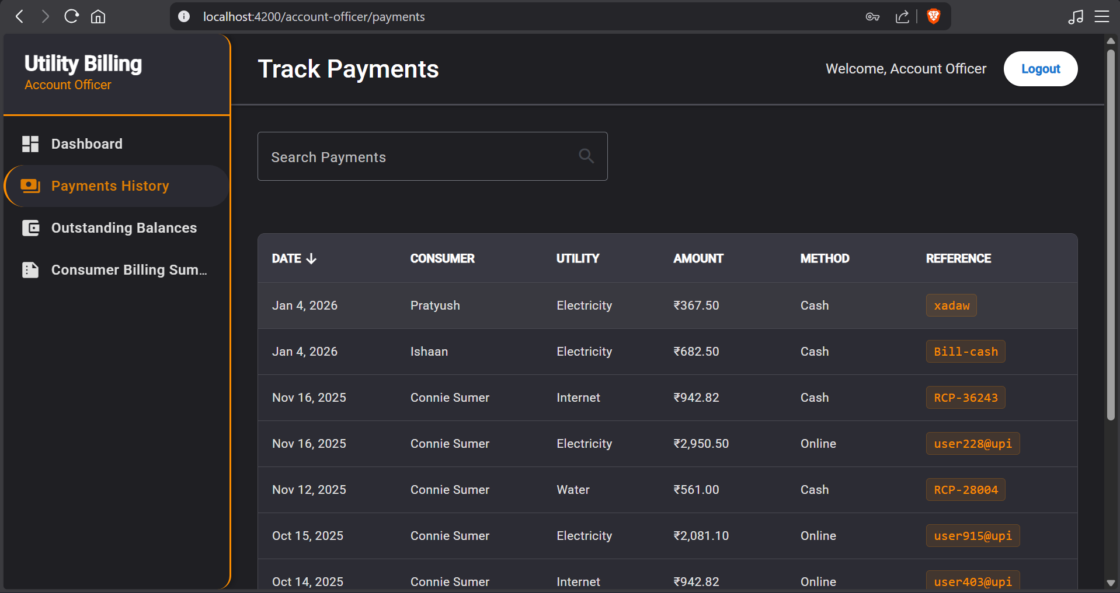

**31. AO – Outstanding Balances page**

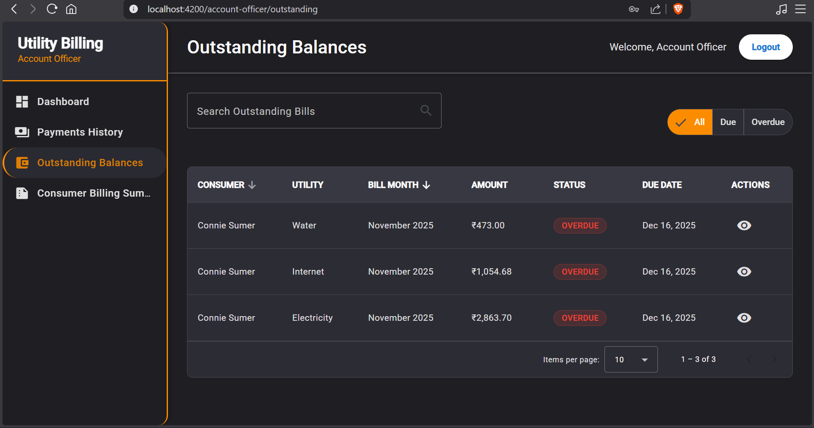

**32. AO – Consumer Billing Summary page**

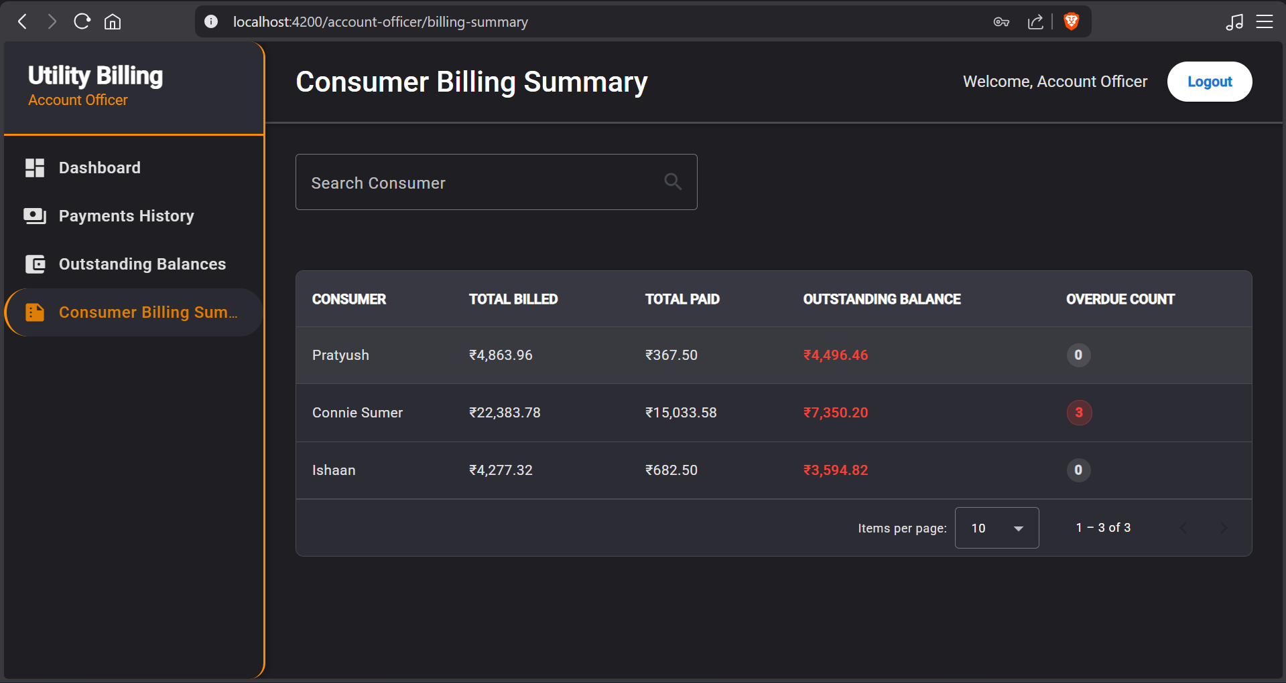

**CONSUMER**

**33. Consumer – Dashboard**

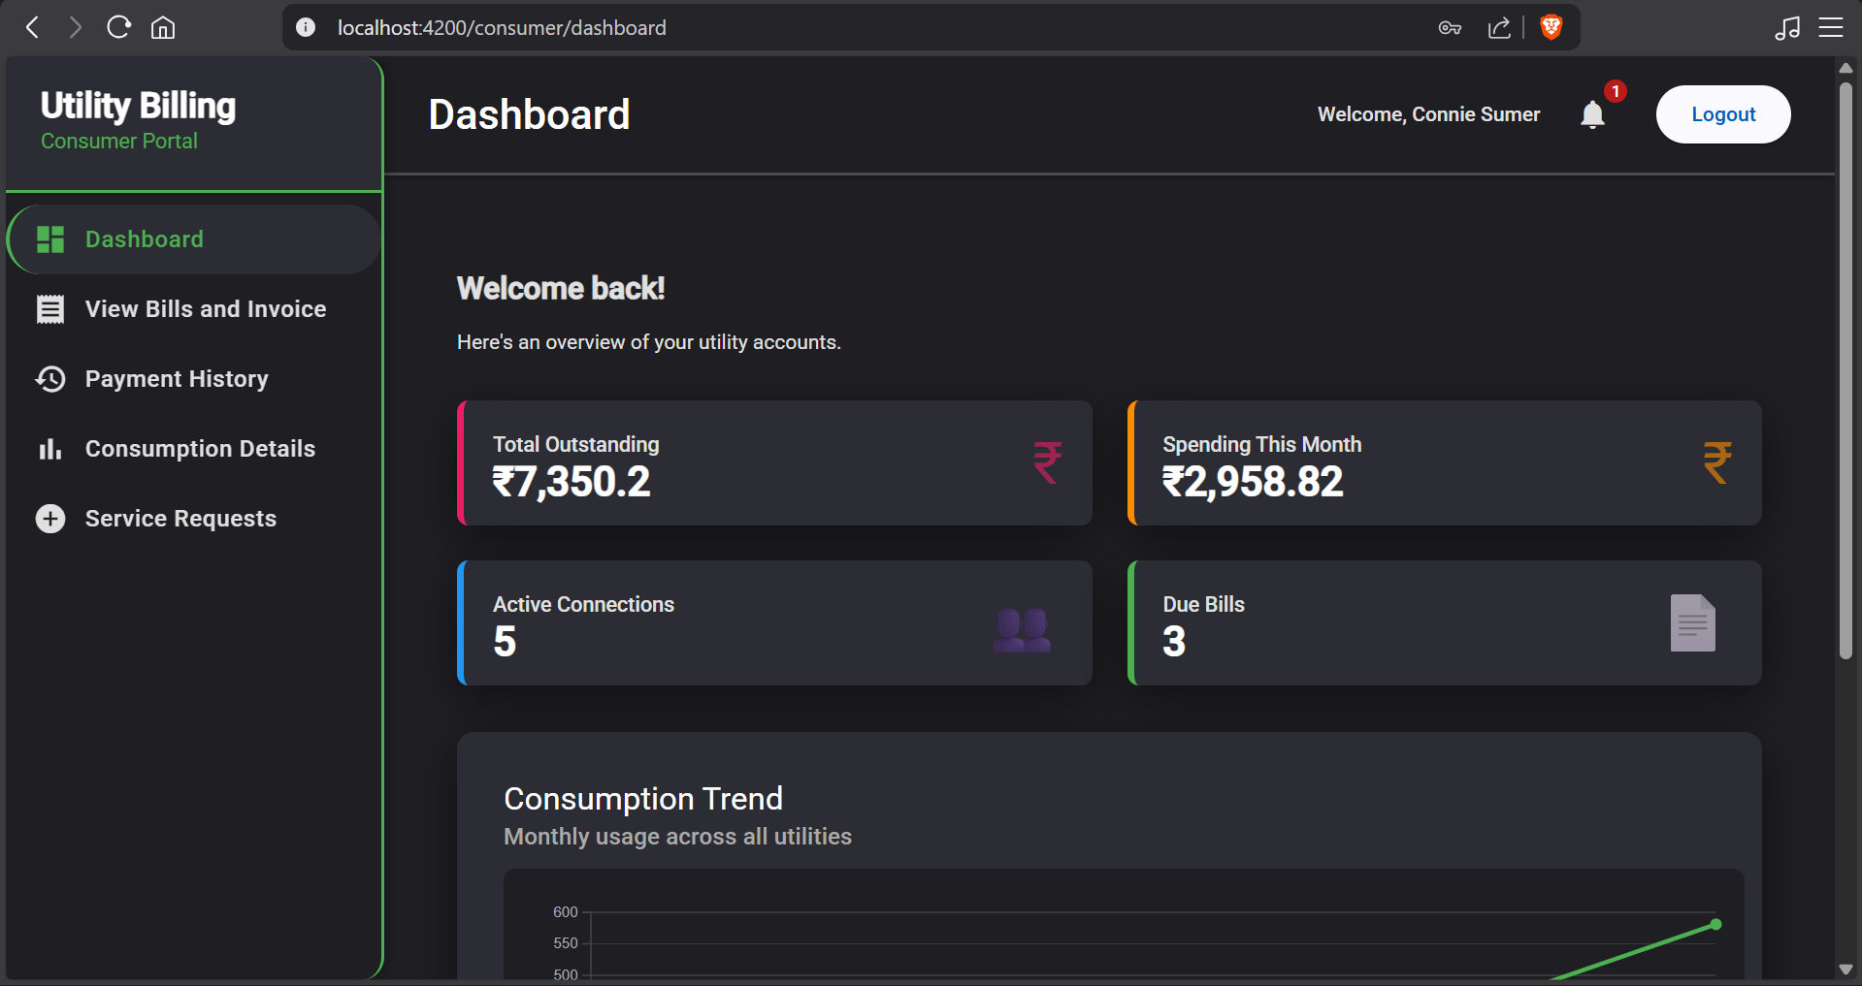

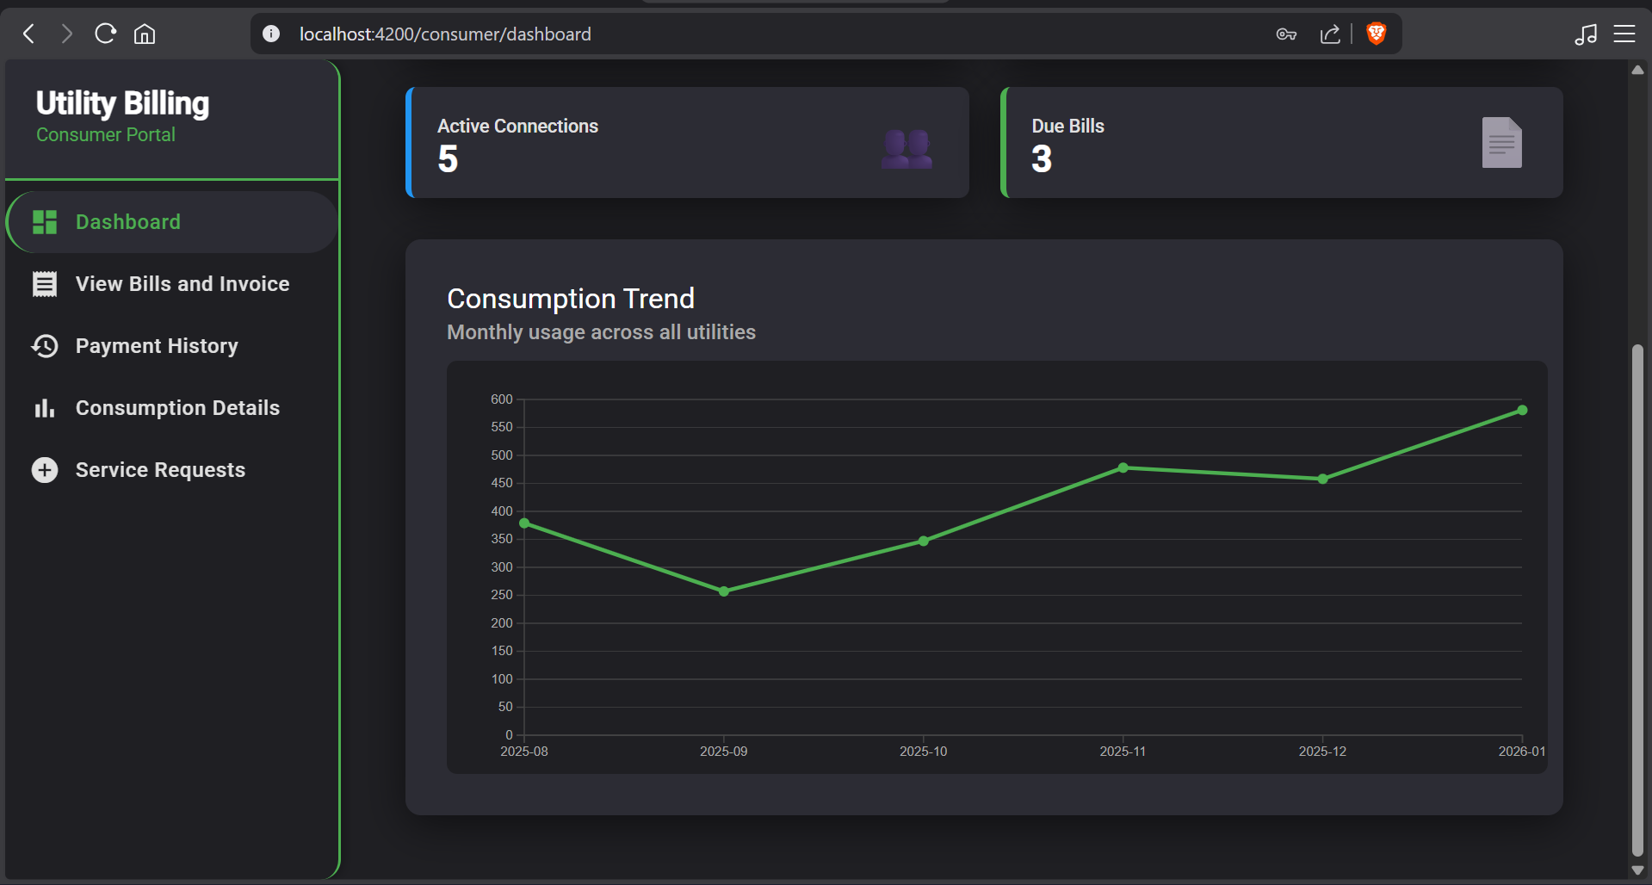

**34. Consumer – Notifications view**

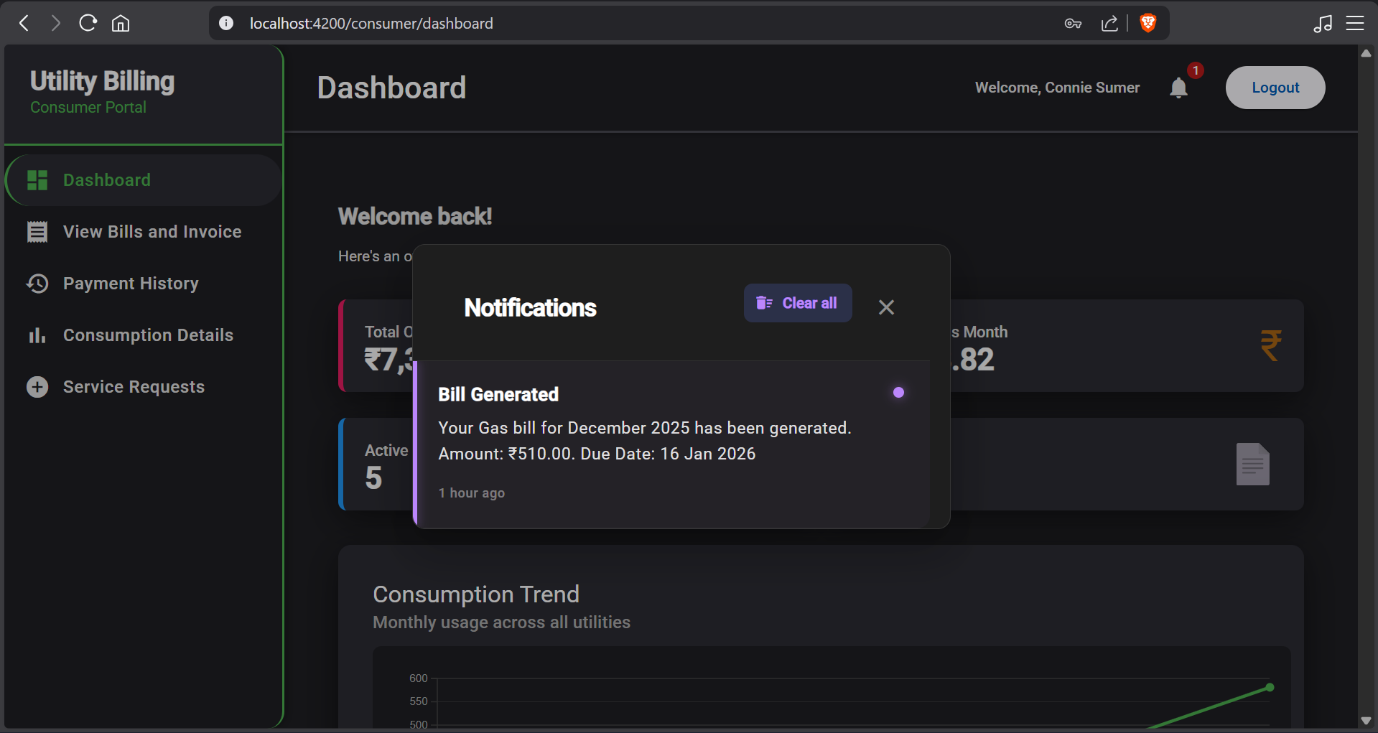

**35. Consumer – View Bills and Invoice page**

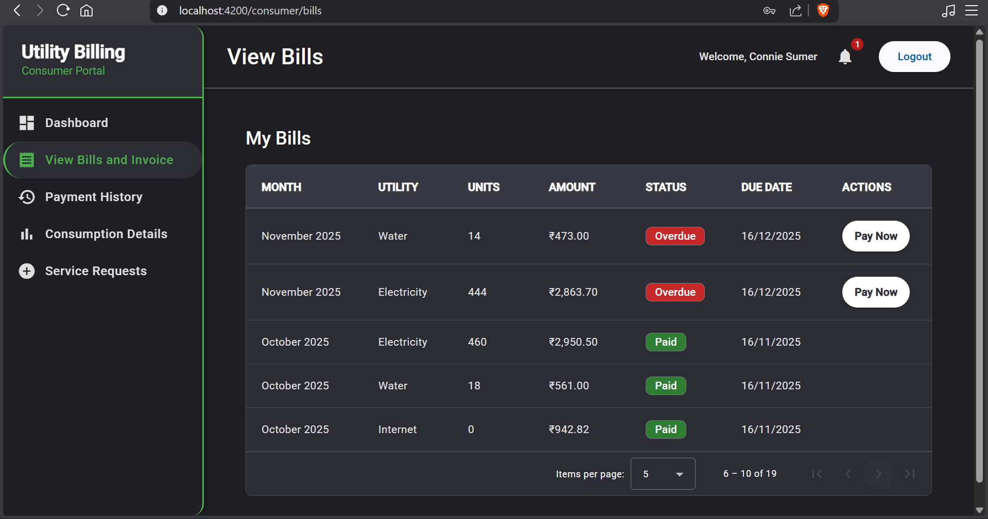

**36. Consumer – Payment History page**

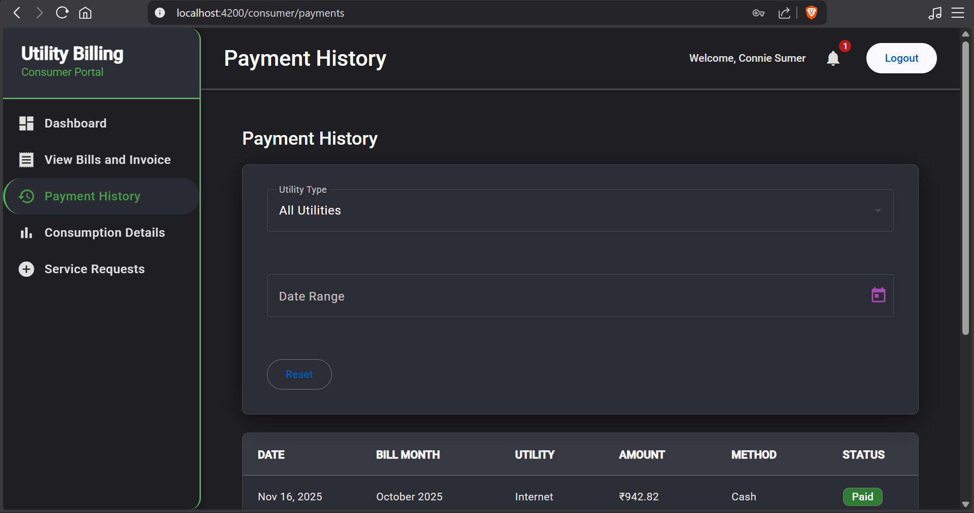

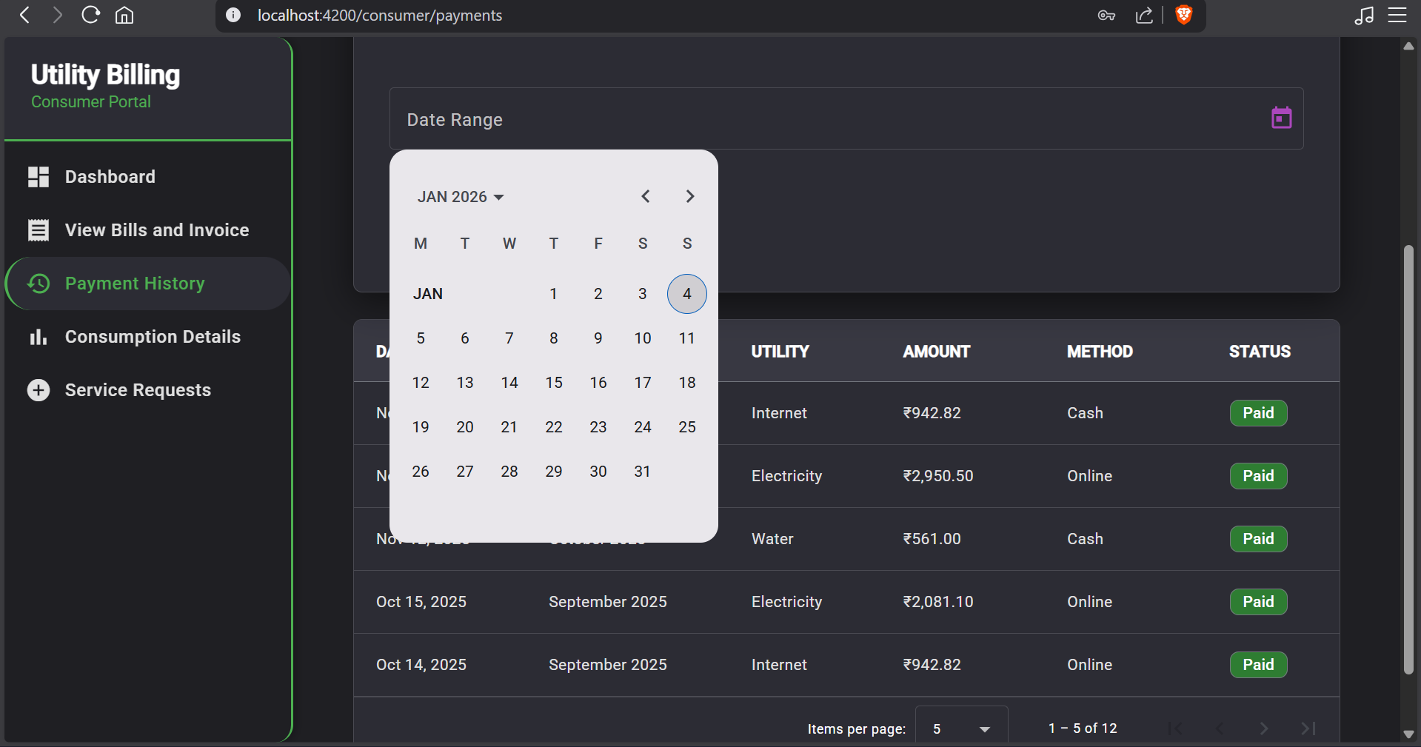

**37. Consumer – Consumption Details page**

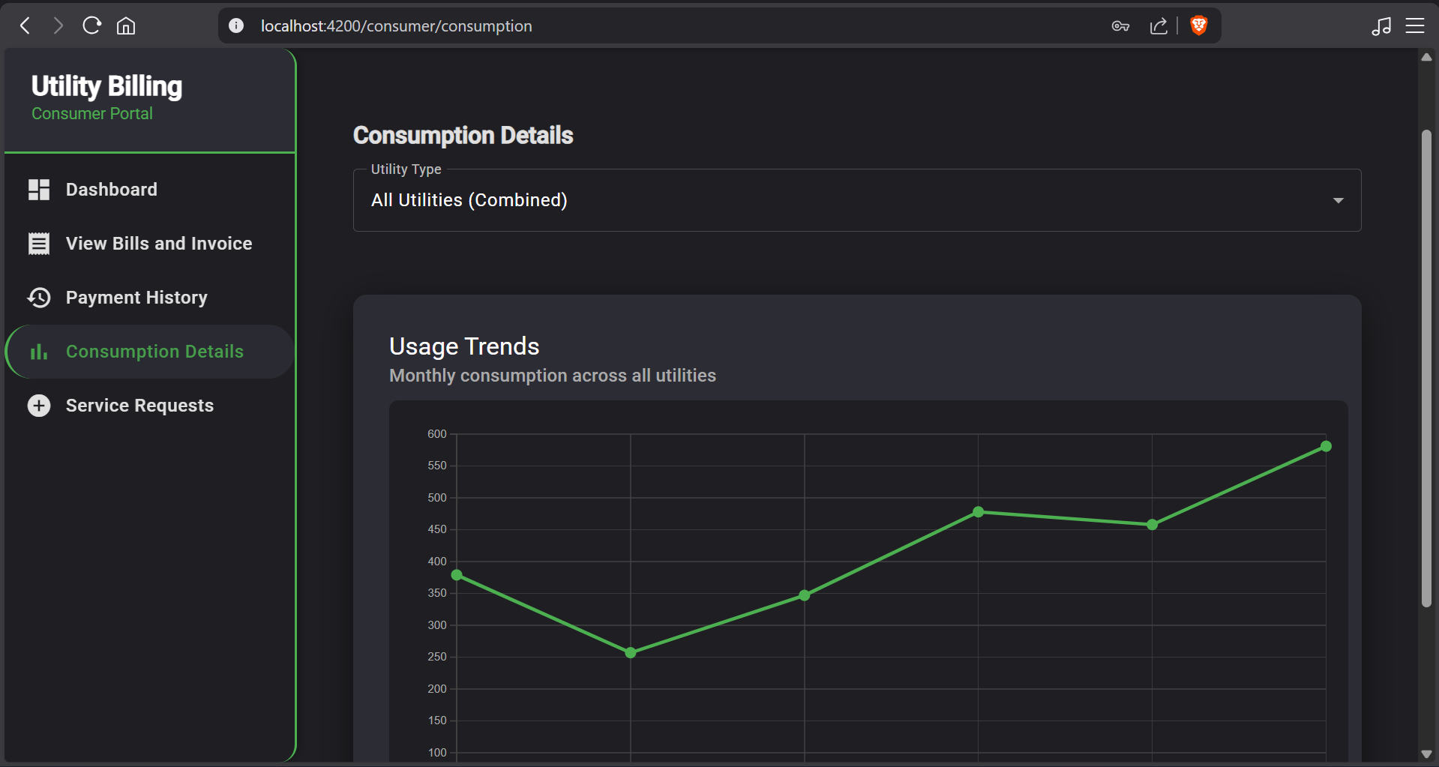

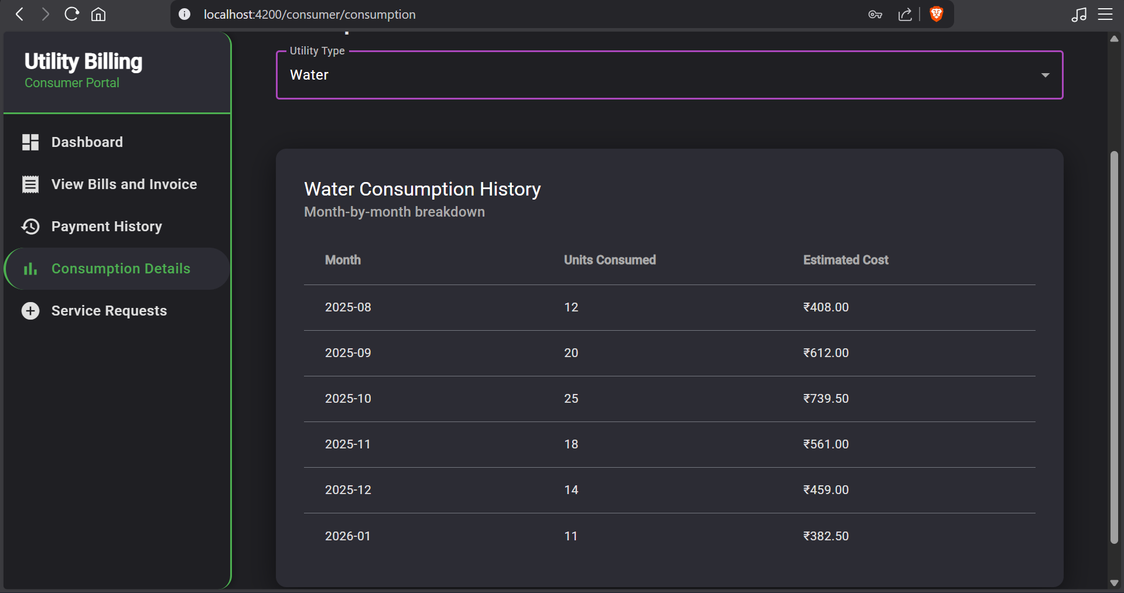

**38. Consumer – Service Request page**

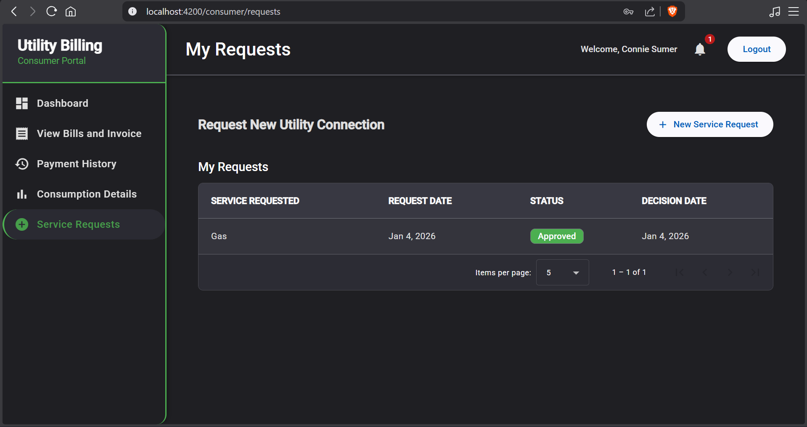

**39. Consumer –Payment form (Online or Cash)**

